Breaking The Ice
Hi, how are you? I’m Sean, I’m with Family Heritage. I work with a bunch of businesses in the area. I was just on my way from talking with Dennis at Capital Roofing and wanted to stop in and introduce myself.

Are you John? (Or if you don’t have a name…) What’s your name?
Is this your place?
How long have you been in business here?
What is it that you guys do exactly?

First Approach
Well, like I said, I’m Sean and I work with a lot of businesses here like Ressler Motors, Williams Plumbing and Wheat Montana…

By the way, are you originally from here?
Well you probably know some of our clients…
… who do you recognize on here?

… What I do for these folks is pretty unique,
So I can show you what I do real quick; and,
then you can decide if you want to talk more; or
if you want to kick me out (big smile).

Do you have a place we can sit down? Or is right over here okay?

(break eye contact and start moving toward a place to sit down or a counter to set your stuff down)

If they ask “What is it that you do exactly?” or “Who are you with?” … go immediately into the Introduction.

If they say they aren’t interested…

Second Approach
No problem. What we do is a little bit unique. Just so you know what it is… I can at least give you the quick version. And if it’s not for you then no big deal. You can kick me out. (big smile)

Do you have a place we can sit down? Or is right over here okay?

(break eye contact and start moving toward a place to sit down or a counter to set your stuff down)

Go immediately into the Introduction

Introduction

Like I said, I work with Family Heritage. We do business with a ton of individual families and businesses in the area like… (mention a few big power names of individual clients and businesses). We do plans to help people financially if they go through something like cancer, heart attack and stroke, or a major accident.

I know those aren’t the most pleasant topics but it seems like …

everyone knows someone who has been through cancer;
heart & stroke sometimes runs in the family,
and an accident doesn’t have to be your fault.

Thinking through your situation… of these big three (show the home page of the Mobile Sales App)… Cancer, Heart/Stroke, or Accidental Injury…

- What concerns you the most?
- Why do you say that one?
- Who have you know that’s been through (cancer/ heart/ accident)?
- What type? How long did they battle it? Were they working at the time?

(open presentation to Stats Pages)
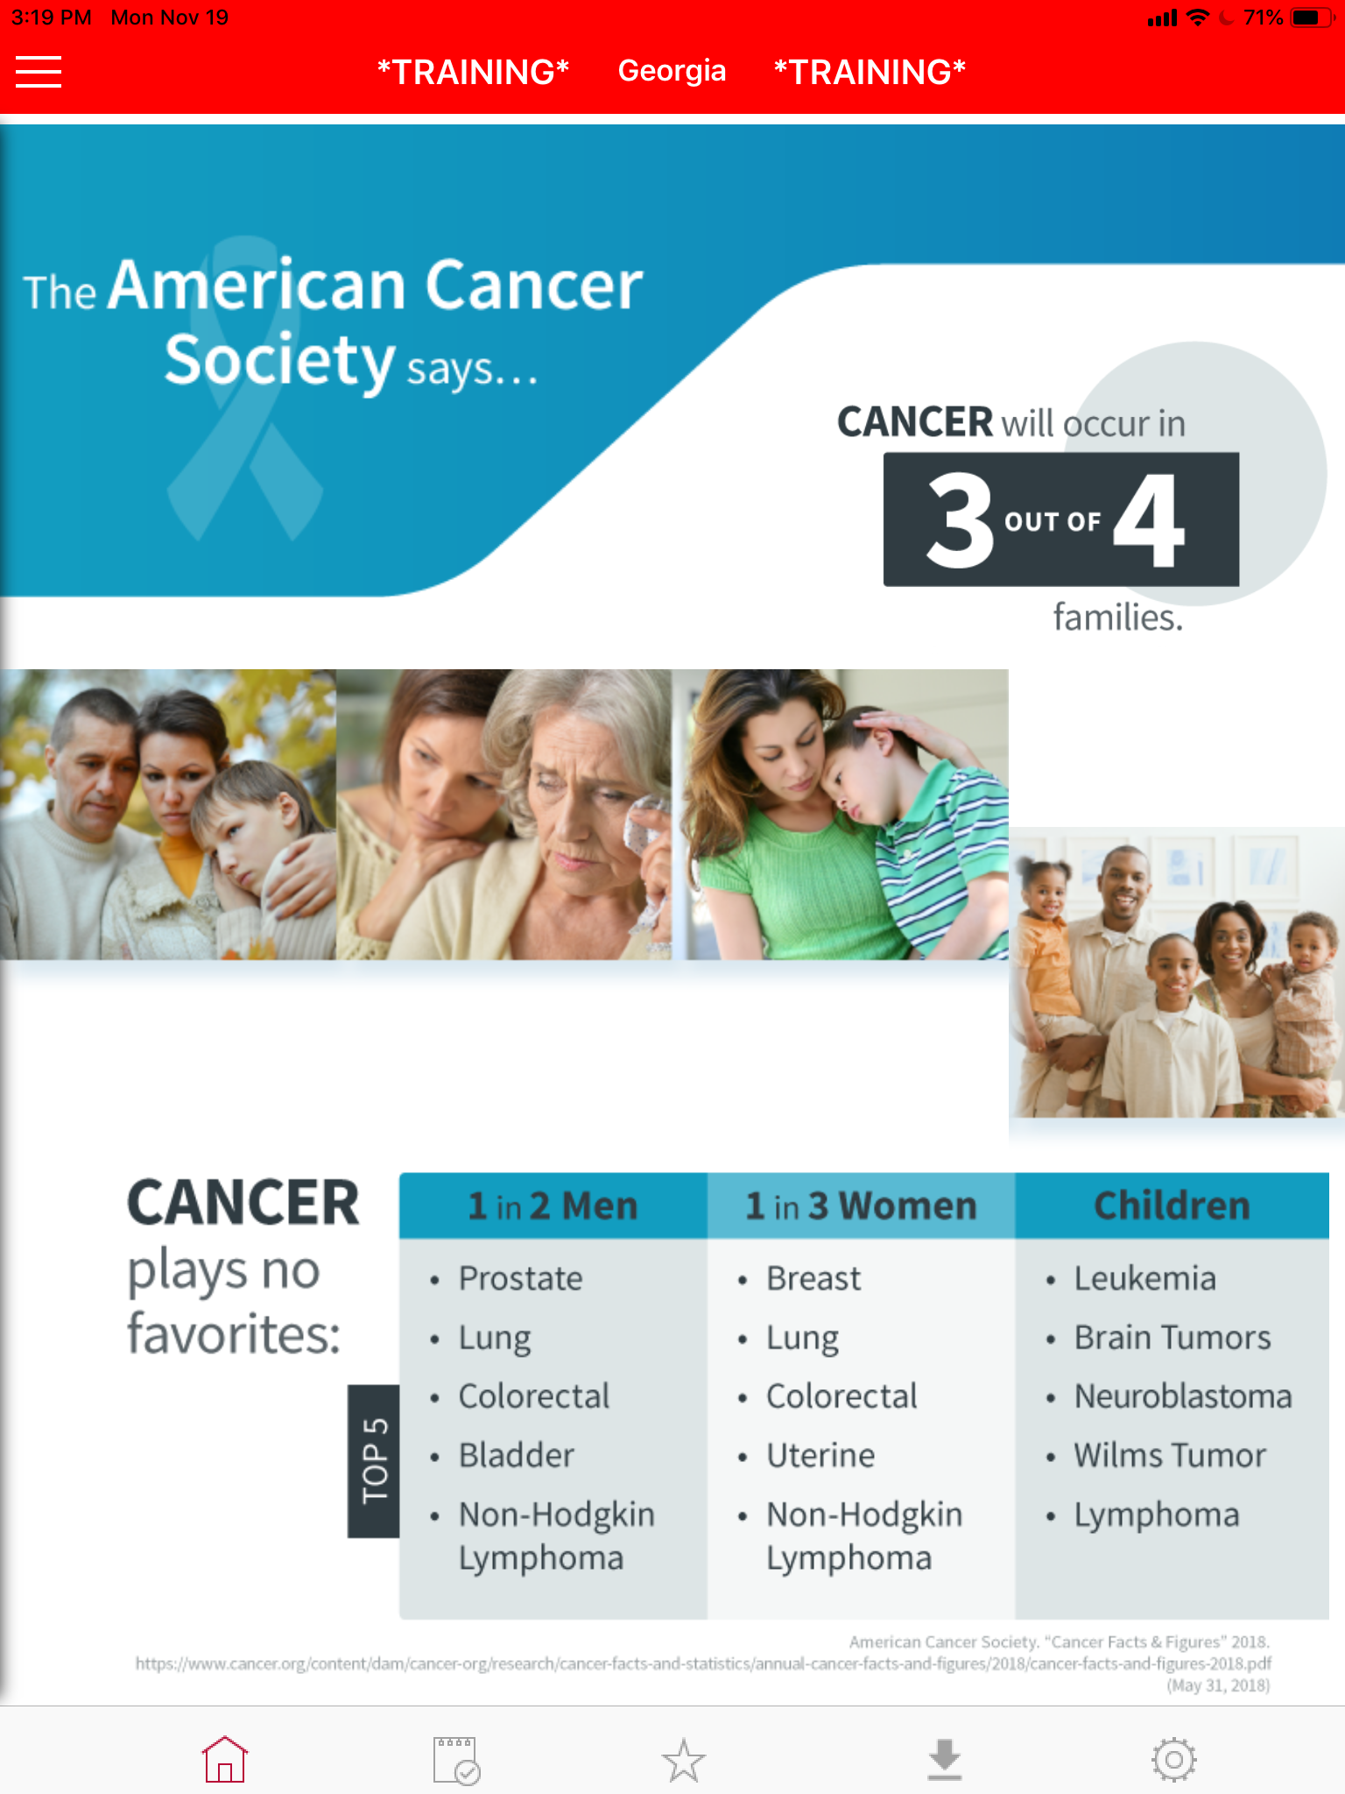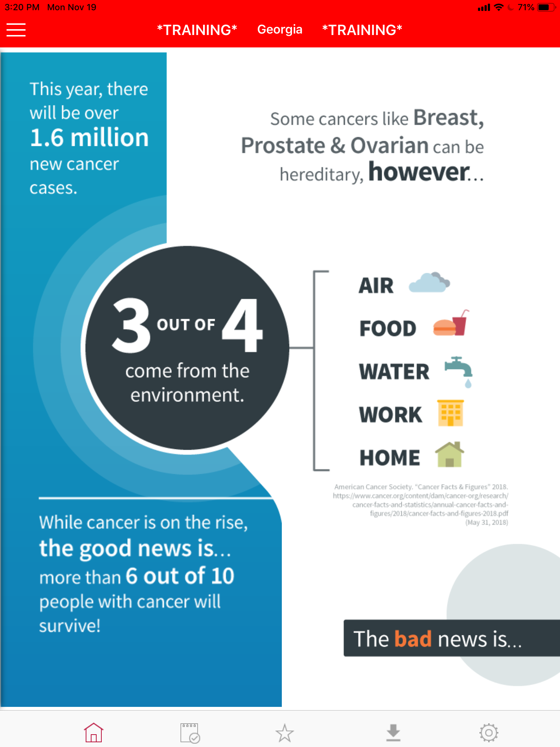
Building the Need - Statistics

You may or may not have seen the statistics before, but…

(Read through the stats pages, quickly highlighting ones that apply to the prospect)
(turn to Direct v Indirect page)
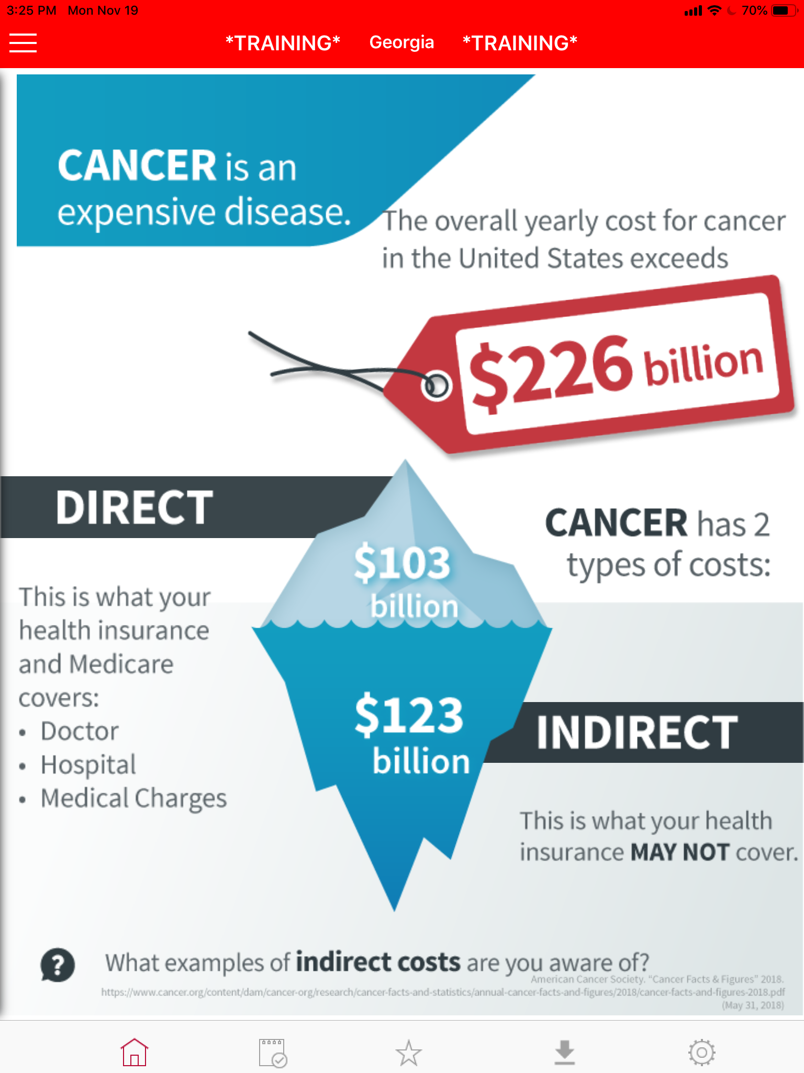
Building the Need – Direct v Indirect

Here is the most important part of what we do. When people understand this part, the rest makes sense.

John, there’s 2 different types of costs that go along with anything serious health wise. Most people are familiar with the direct costs. Those are the doctor bills and medical expenses, and that’s what major medical health insurance is for. What do you do for health insurance? Great, hopefully your health insurance will take care most of those direct costs. We don’t have anything to do with that part.

What we talk to people about are the indirect costs. Do you know what I mean when I say indirect costs? (Wait for response; nod) That’s part of it.

(*** Critical Need Finding Question ***)

We’ve found the indirect costs are different for everybody’s situation. Thinking through your situation… (restate their situation: “as a business owner”, “being the only income at home”, “young family with kids”, etc)

… If you were to go through a major battle with (cancer/ heart disease/ accident)… for 3 months, 6 months, a year or longer… how would that impact you financially? (listen, nod)

Why would you say that? (give them to elaborate, listen, nod)

That’s exactly what this is for.

(flip page to Indirect Costs)
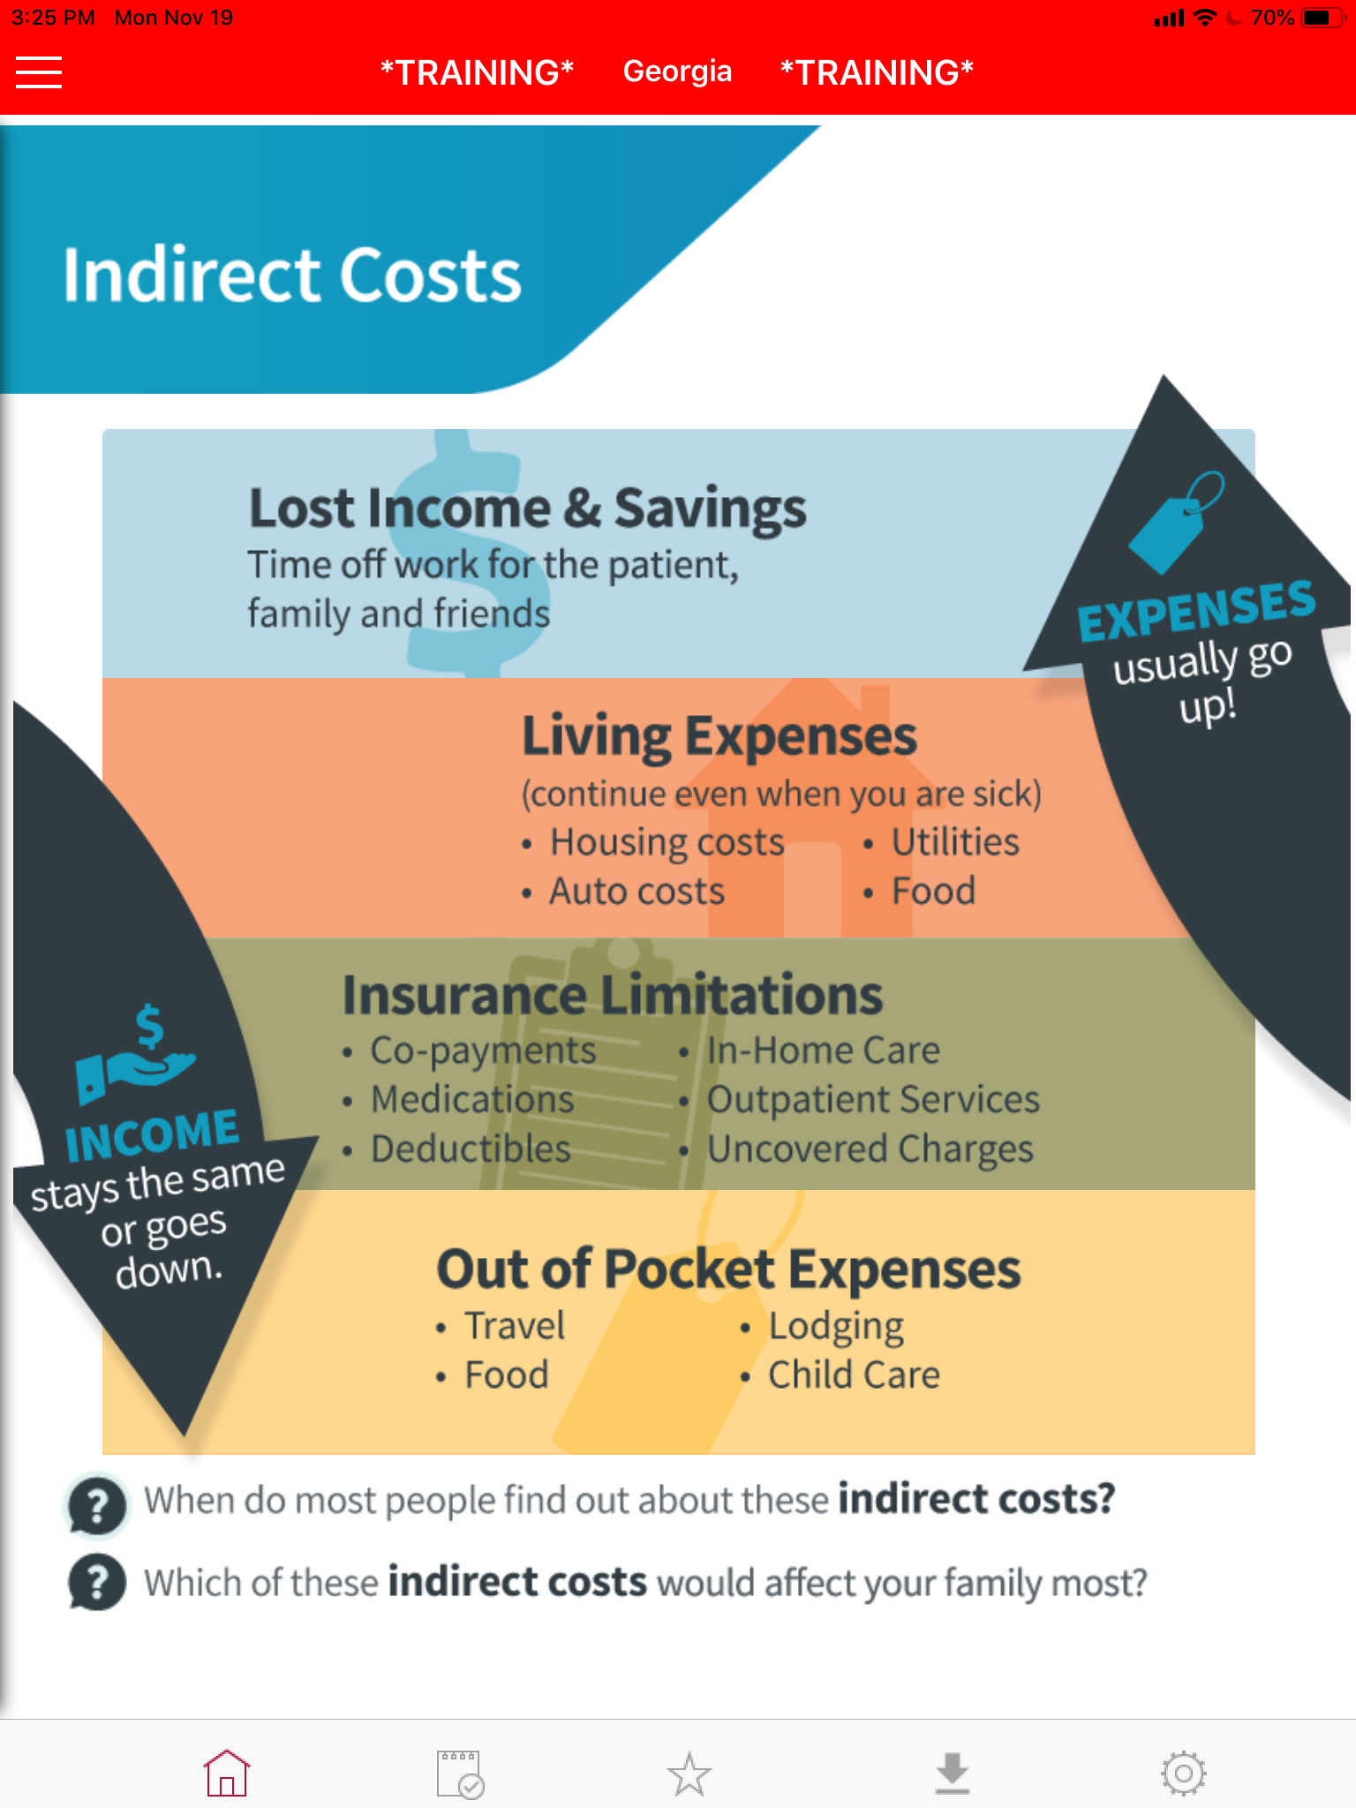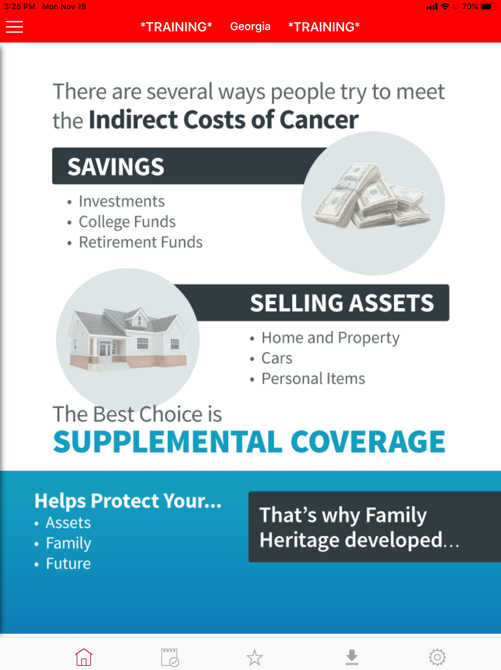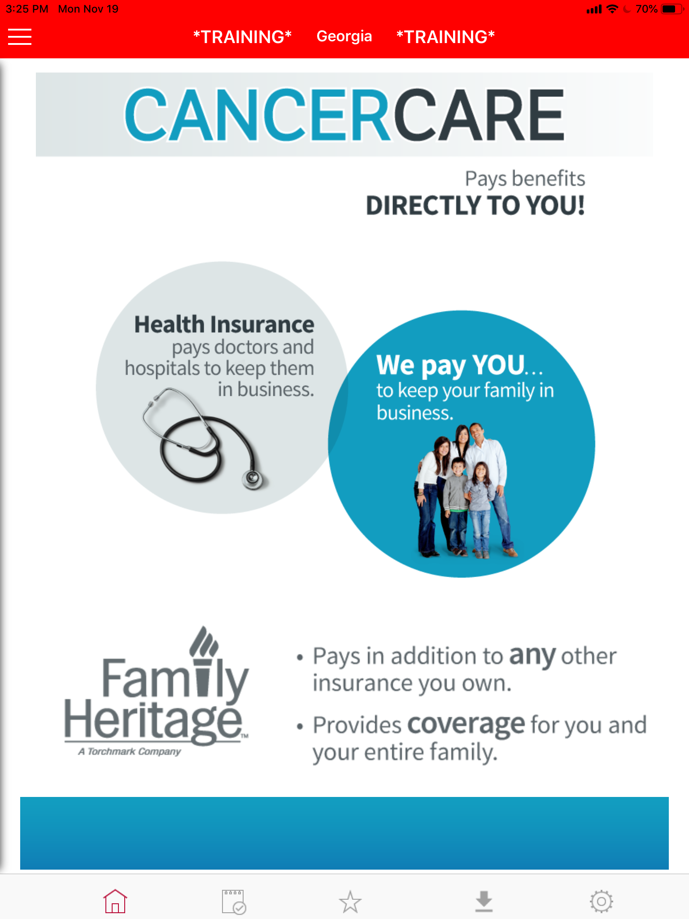
Here are a few more examples of common indirect costs.

(Read directly off the page, through each indirect cost quickly. Elaborate on any they didn’t come up with themselves.)

When do you think most people realize those indirect costs?

Thinking through your situation, which of those indirect costs would affect your family the most?

(flip to Savings and Assets page)

There are several ways to meet those indirect costs…

(read savings and assets page line-by-line)

That’s why Family Heritage developed…

(flip to CancerCare / CardiaCare / InjurCare page)

Cancer Care Plus / CardiaCare Plus / InjurCare Plus

It covers (cancer / heart & stroke / accidents) and the “plus” part is a rider you can get with it that covers any reason you go into Intensive Care.

If something happens, it pays benefits directly to you! Health insurance pays to doctors and hospitals to keep them in business. We pay directly to you to keep you and your family in business! (read through entire page, word for word).

Here is an example of how it works. (quickly reference a client testimonial)

(flip to Three Reasons page)

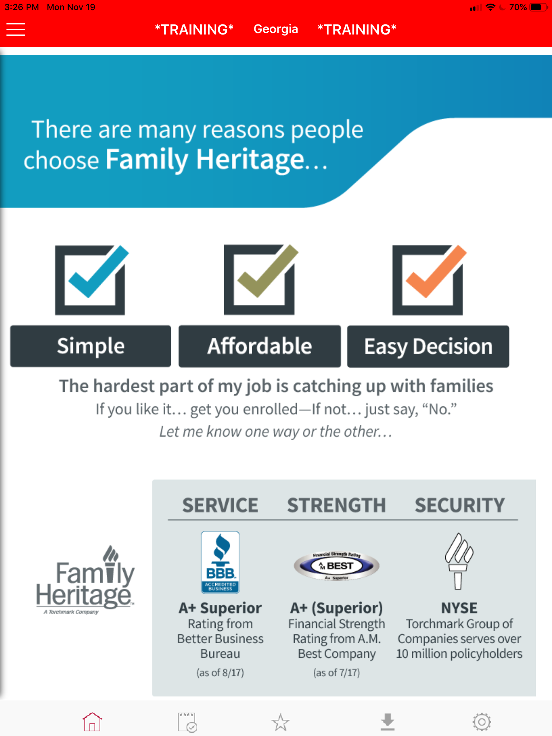
You probably know some of our policyholders… (pull out client list and mention power names in the community)

There are many reasons people choose Family Heritage…

It’s really SIMPLE: You’ll know today whether or not this is for you.

It’s AFFORDABLE: We have plans to fit different budgets.

It’s an EASY DECISION: What makes it such an easy decision is that you actually get 100% of the premium you pay refunded back to you. And I’ll show you how that works in just a minute.

Buying Atmosphere

So the big questions are… what does it costs? what does it cover? and how do you get your money back? … and that just takes a few minutes.

But before I do that I want to … share something with you & ask you a favor.

What I’ll share with you is… the hardest part of my job is catching families in time? Do you know what I mean by that?

Yeah, that’s right. Before it’s too late.

So I’ll show you how this works and if it makes sense we can get you enrolled today while you are healthy and qualify. If it doesn’t make sense… that’s okay too. I’ll leave you in a good mood either way. (big smile)

The favor I ask is to just let me know one way or the other when I’m done. Is that fair enough?

(flip to Benefits page)

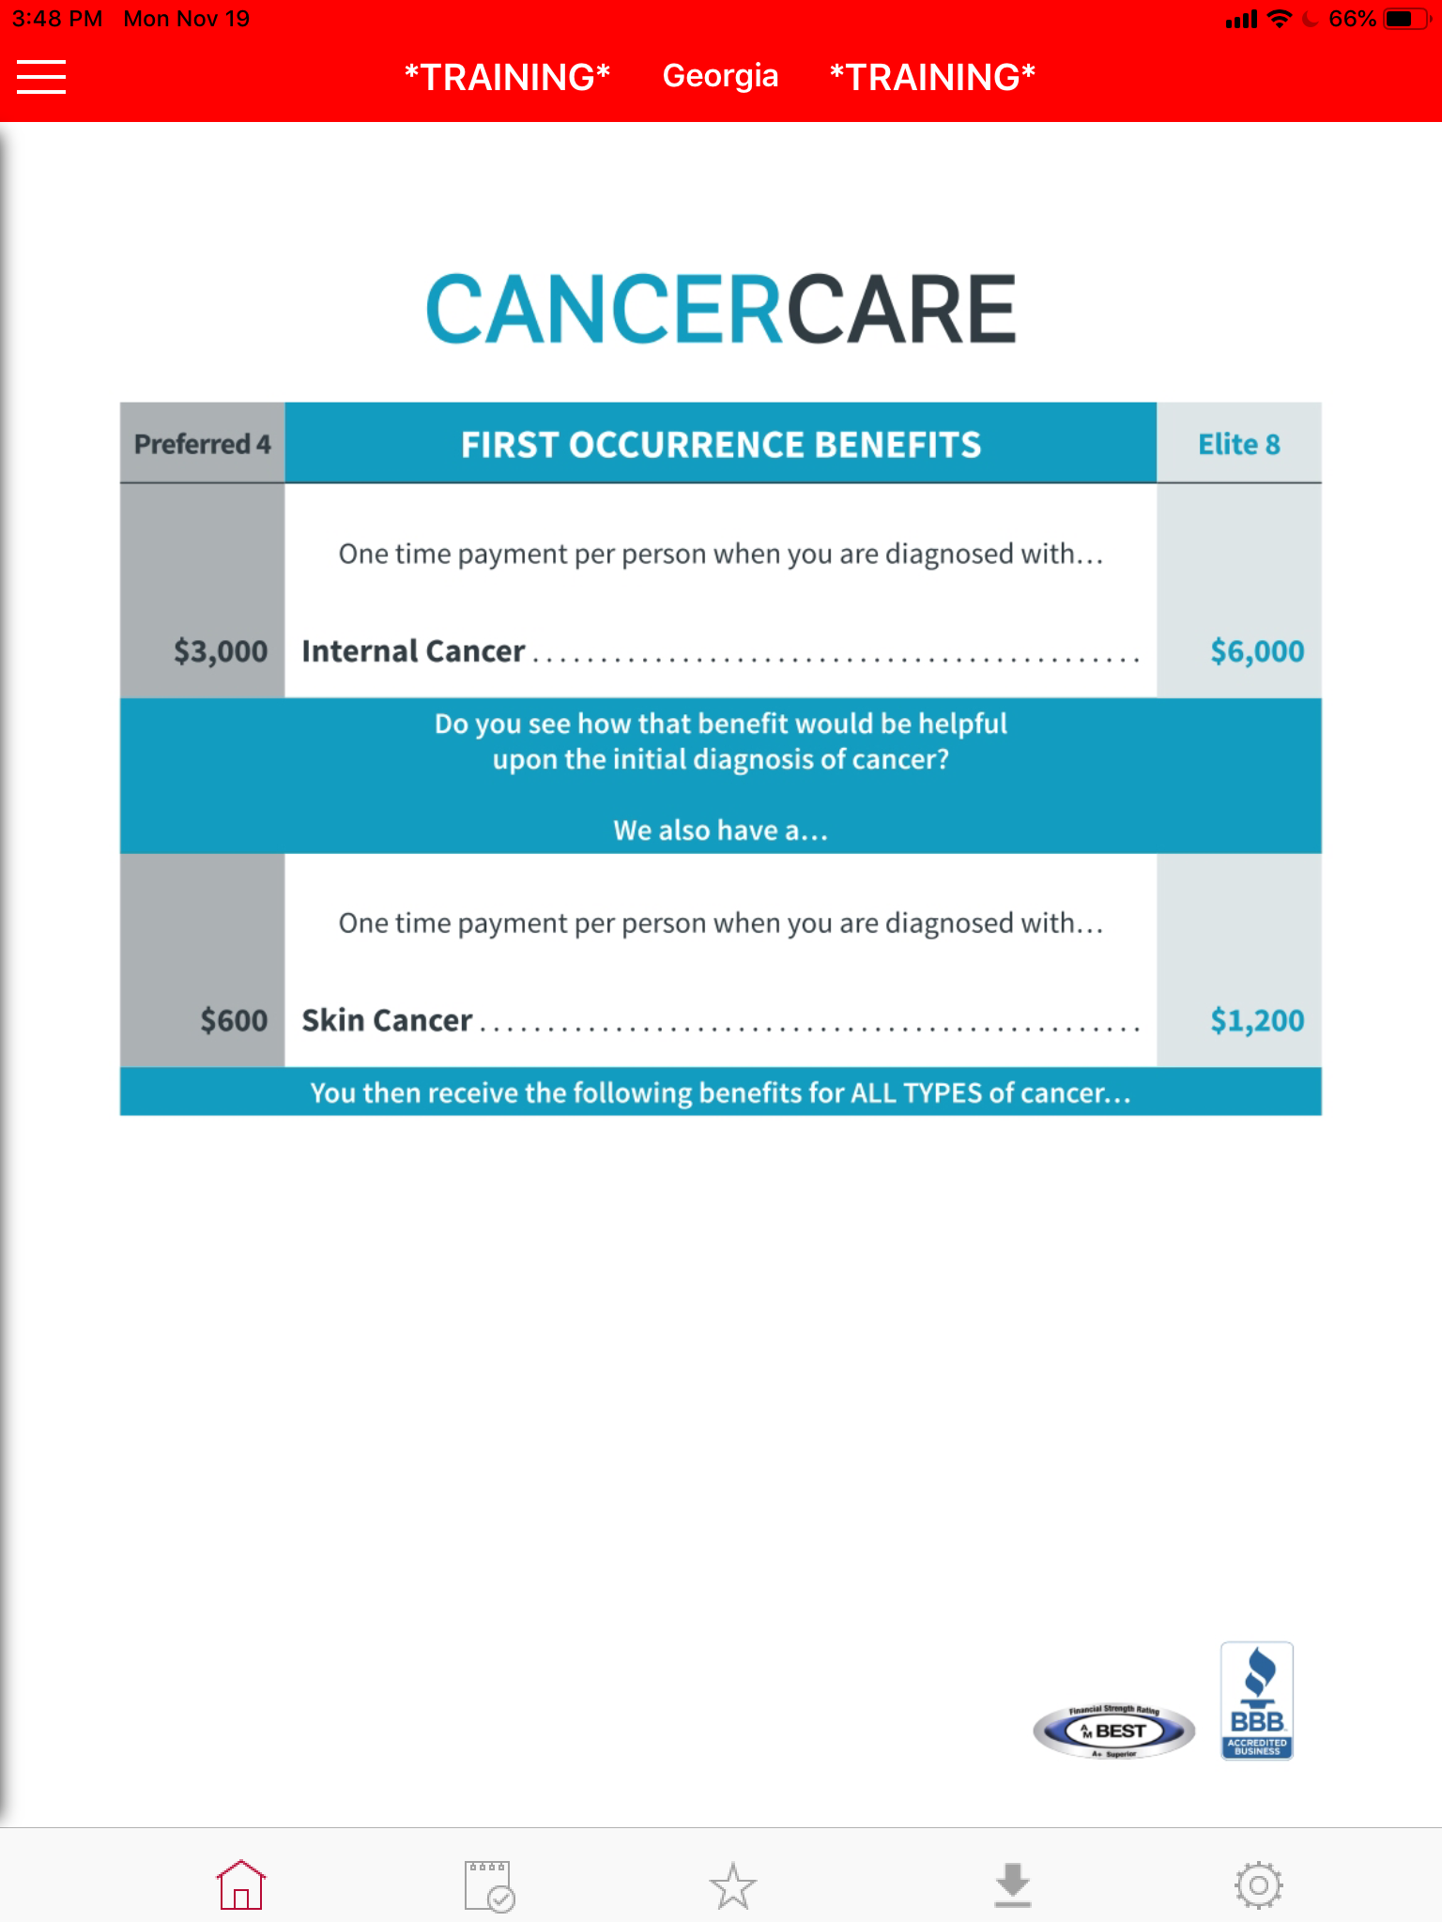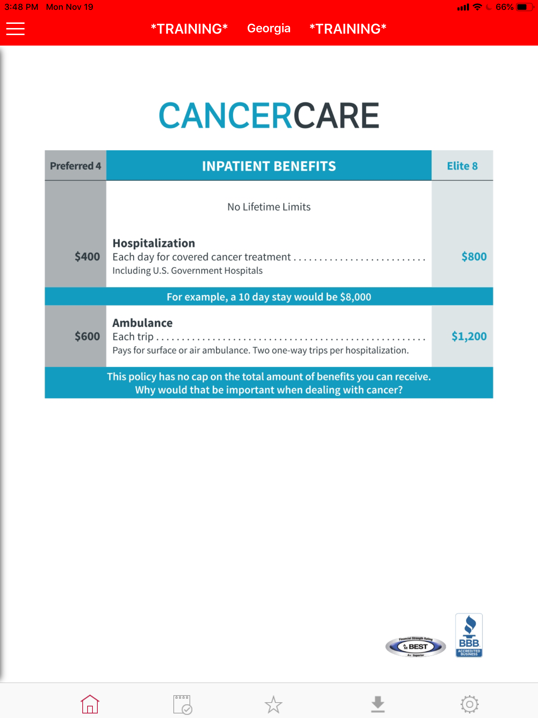
Benefits Presentation

There are 4 levels of coverage. There’s the Elite 8. It’s the best plan. It pays you the most if something happens. The Preferred 4 will cover the same things, it just pays out half as much. The Standard 2 isn’t shown but it pays half the Preferred and the Base 1 pays half that. To keep it simple, I’ll go over the Preferred plan but you have different options.

If anyone in the family was diagnosed with cancer; right off the bat we’d pay you $____. Now ____, that’s not a million dollars but why do you think we give you a big check right away? (let them answer)

(next page)

That just gets you started. After that we pay you based on what you go through for as long as you go through it. For example, every day you’re in the hospital for cancer treatments, this plan will pay you $___ per day with no lifetime limits. If you are in the hospital, what are you not doing? (they should say “working”) Exactly. This policy has no cap on the total amount of benefits you can receive. Why would that be important when dealing with cancer?

(next page)
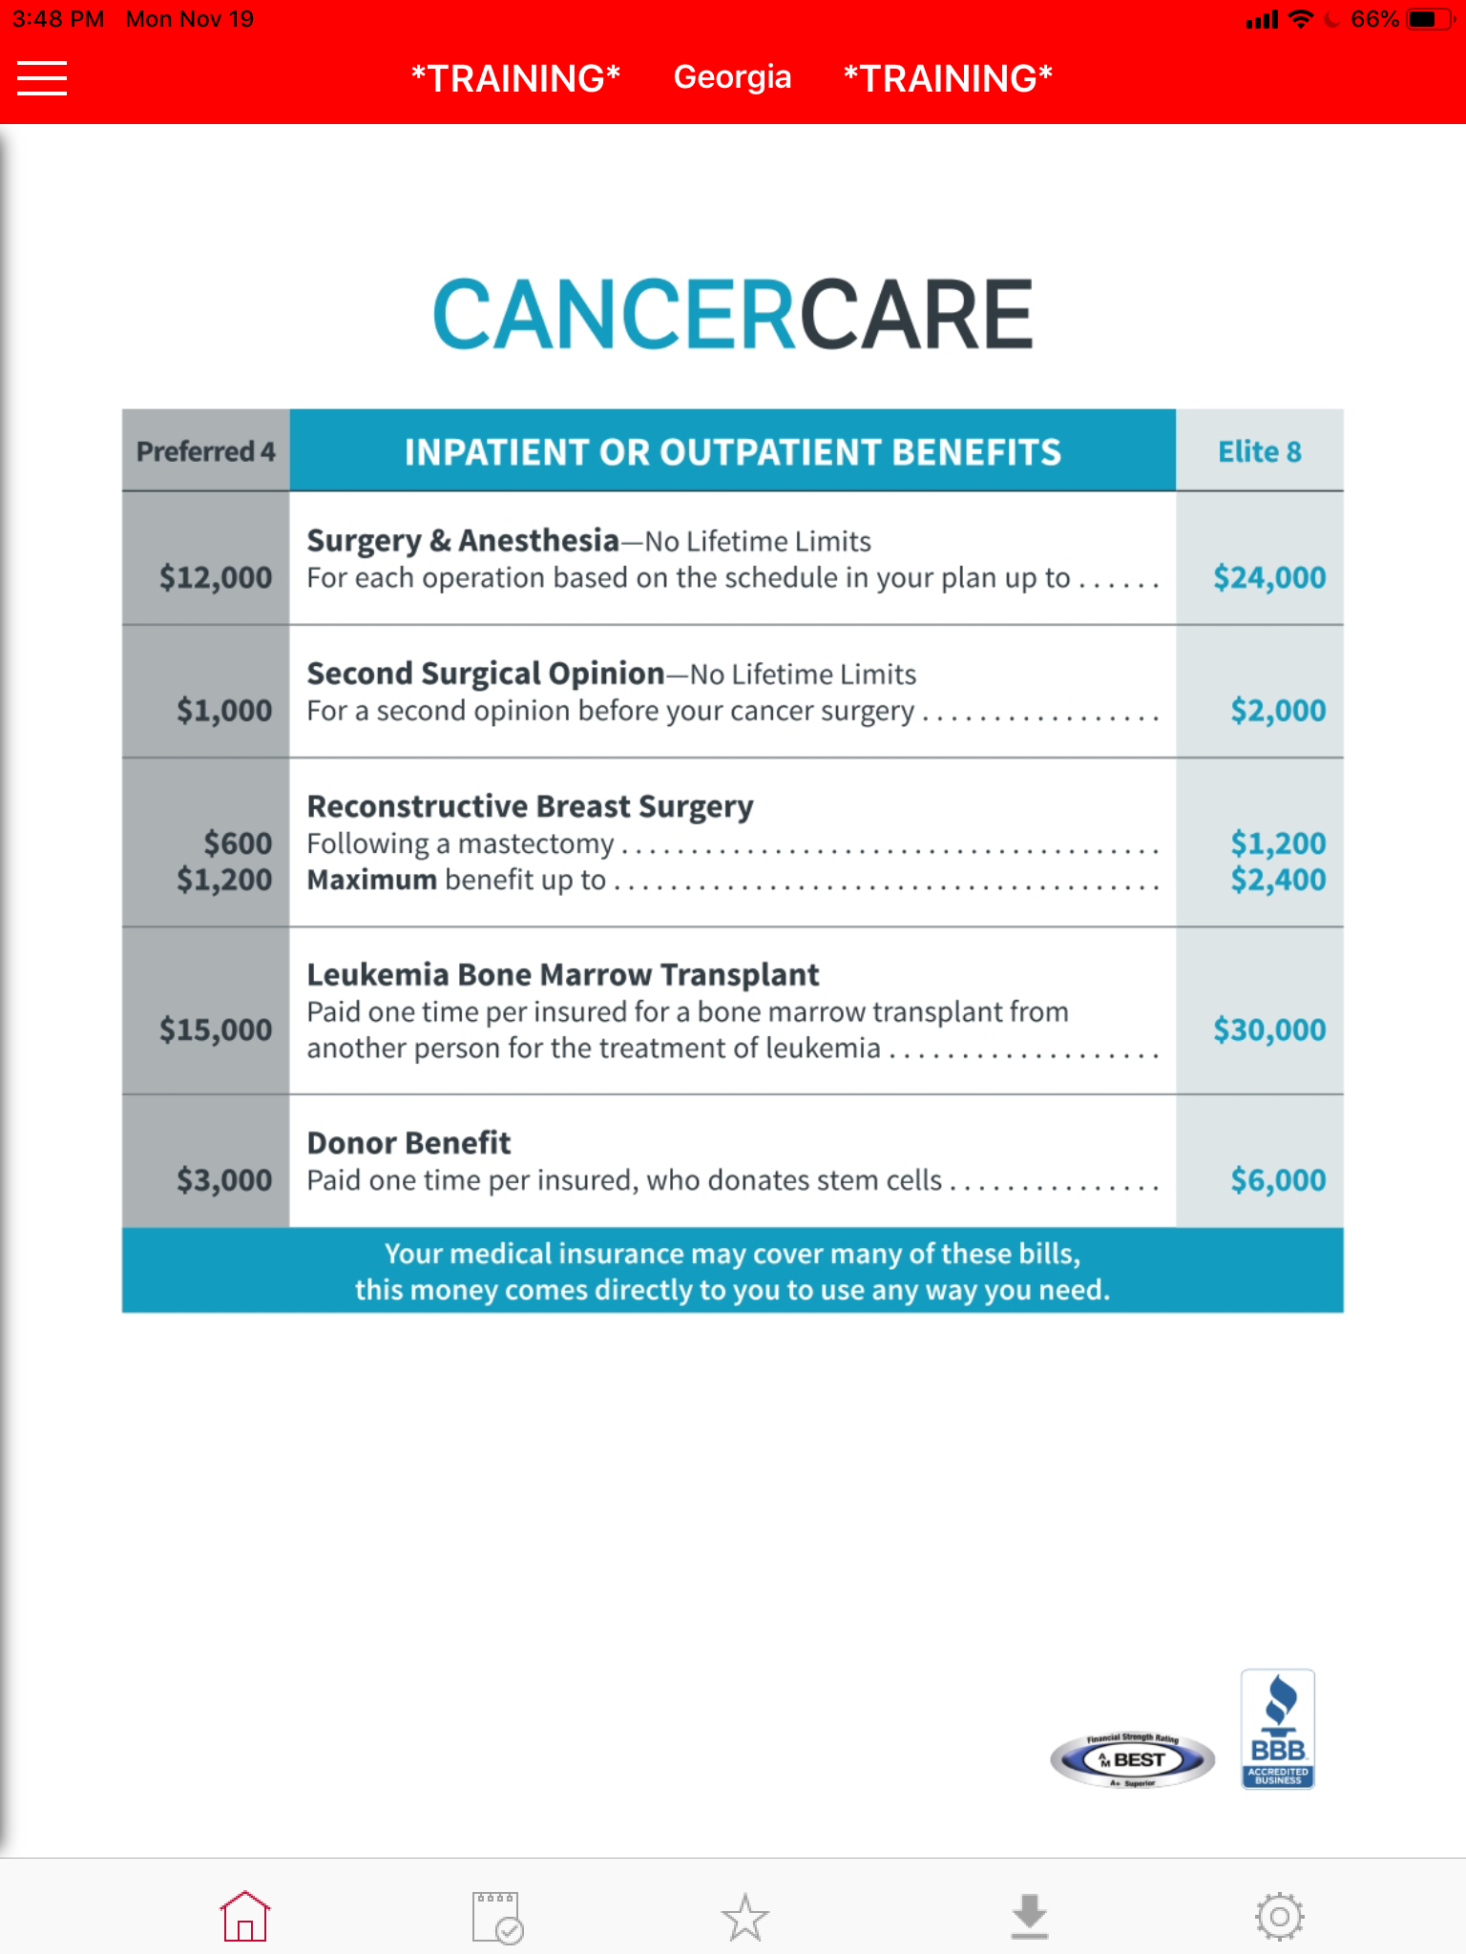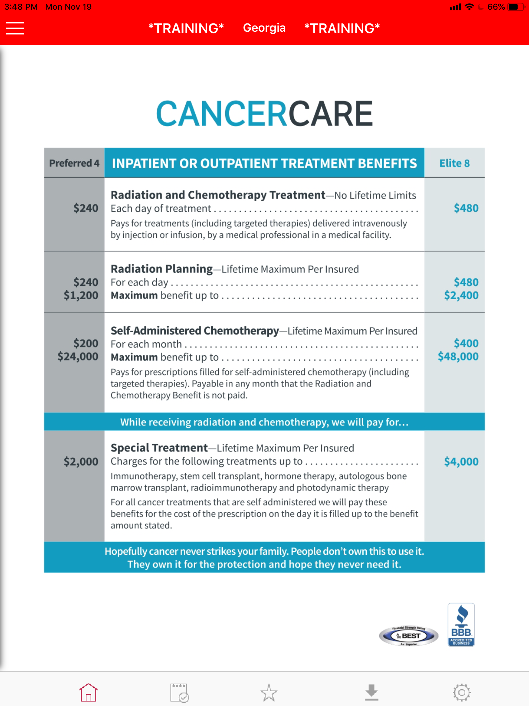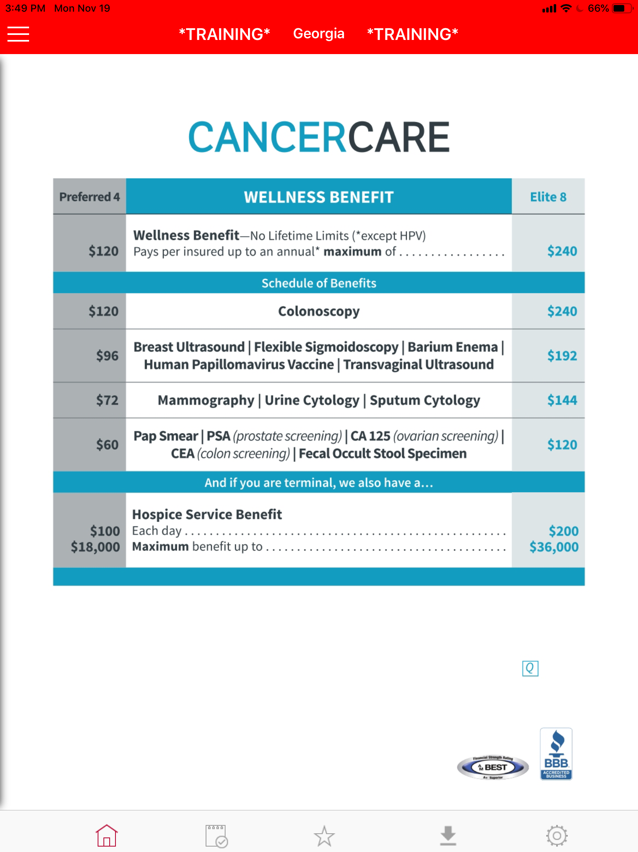
The rest of the policy works the same way. Whether it’s inpatient or outpatient. For each surgery, we pay up to $____ per surgery.
_____, your medical insurance may cover many of these bills, this money comes directly to you to use any way you need.

(next page)

Every single day that you’re treated with chemo or radiation, we pay $___ per day. That can really add up.
Hopefully cancer never strikes your family. People don’t own it to use it. They own it for the protection and hope they never need it.

(next page)

Would you agree that prevention and early detection are the best ways to fight cancer? That’s why we have a Wellness Benefit. We will send you cash for doing these listed cancer screenings. You don’t have to have a diagnosis to claim on this benefit.

From what you’ve seen so far, what sticks out the most: Is it that it pays cash right to you, and you’re in control of where the money goes? Or is it just that it cover so much with no limits?

(next page)

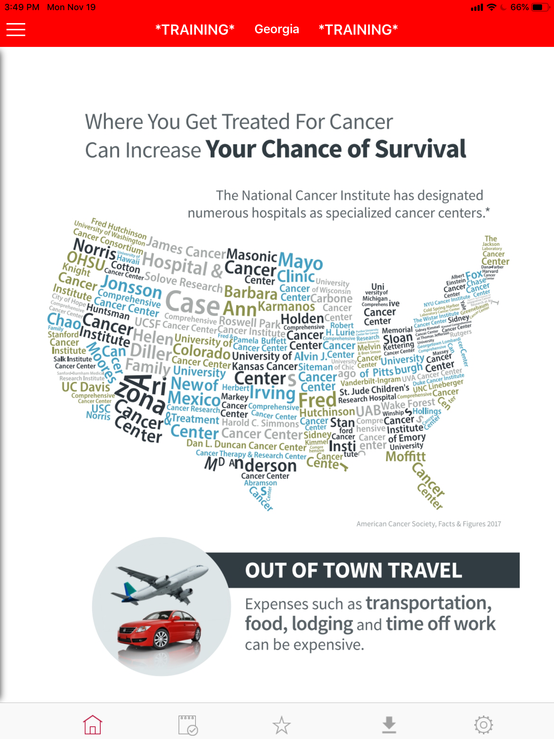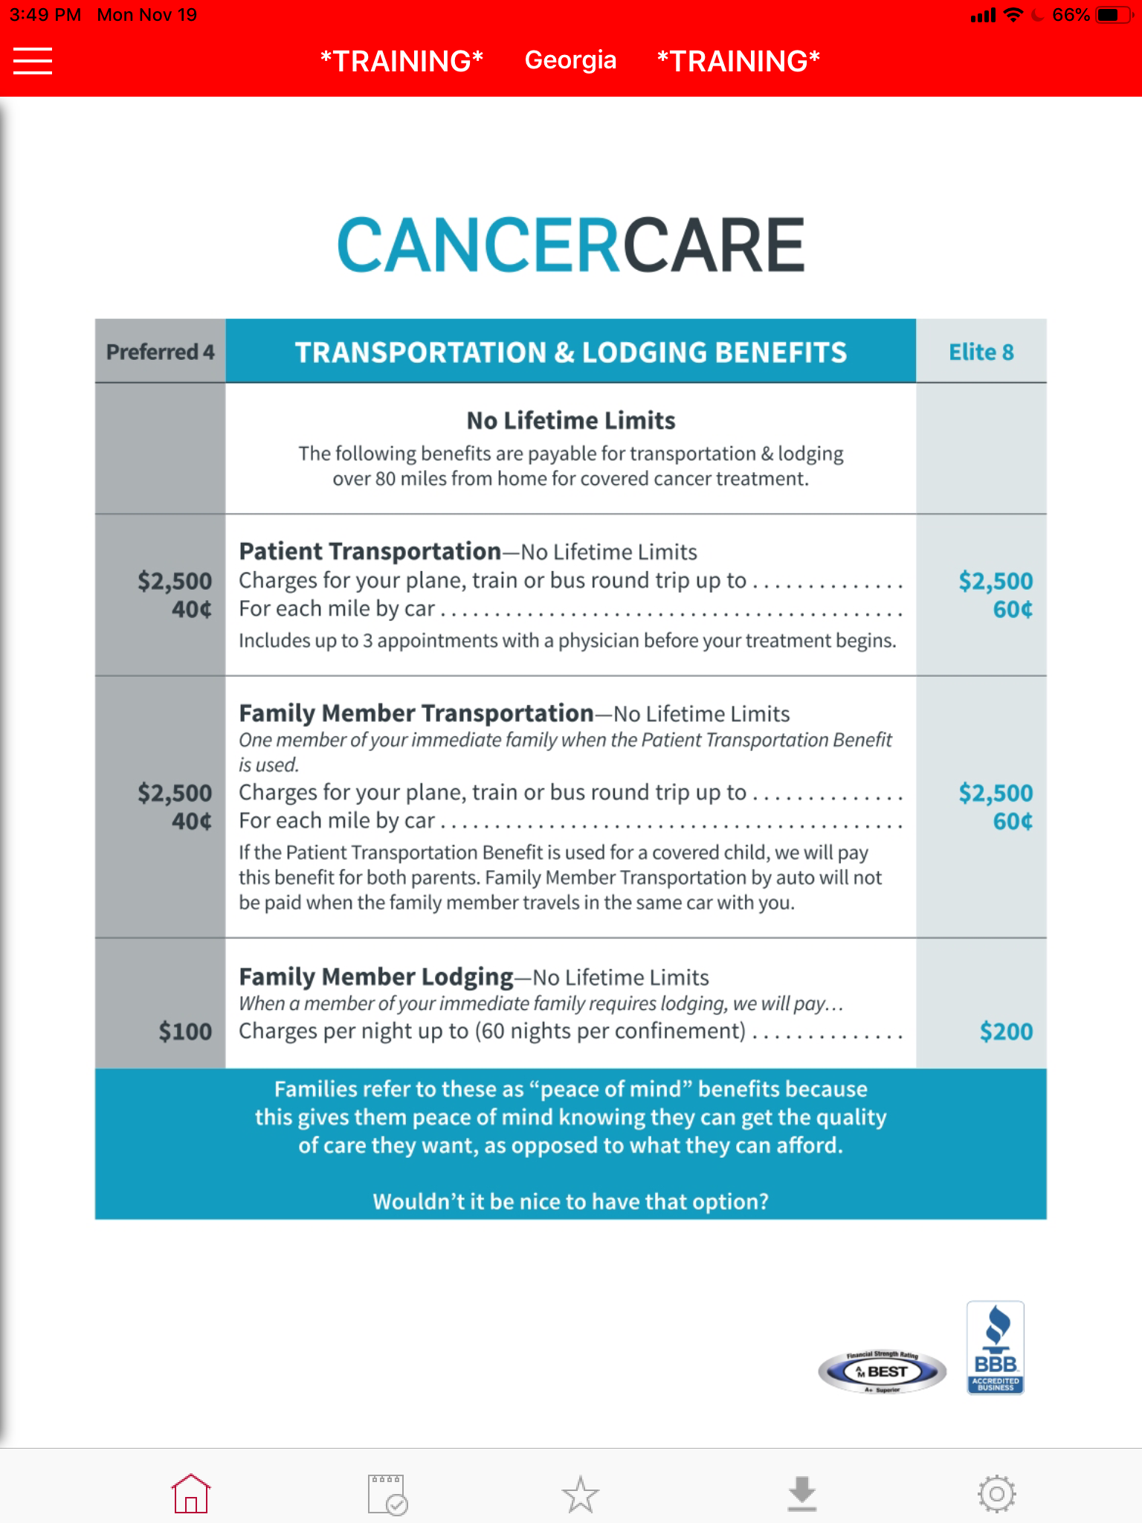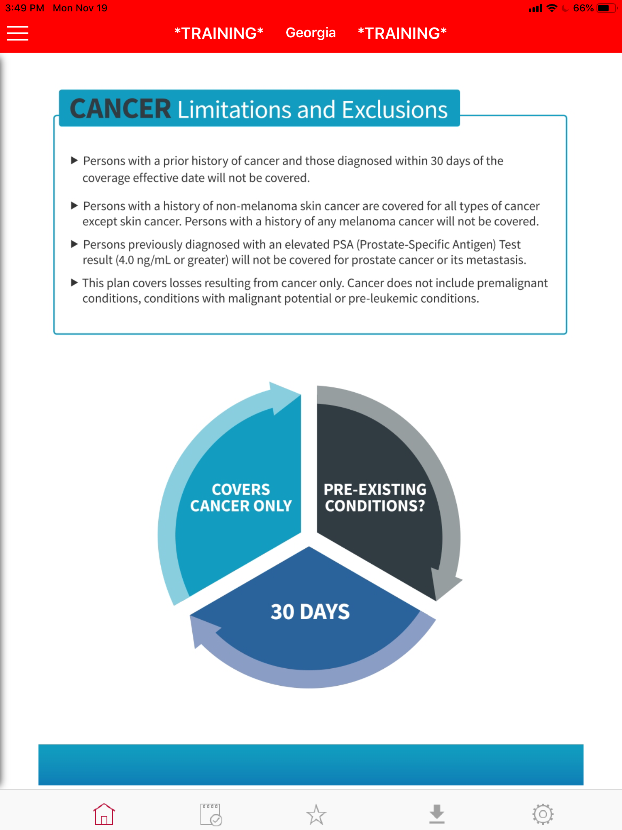

It also covers travel if you go more than 80 miles from home for treatment. Families refer to these as peace of mind benefits because this gives them peace of mind knowing they can get the quality care they want as opposed to what they can afford?
Wouldn’t it be nice to have that option?

(next page)

Cancer Limitations & Exclusions

Has anybody had cancer before? Elevated PSA test?
It takes 30 days to become effective.
What I have shown you so far is for cancer only.

(next page)

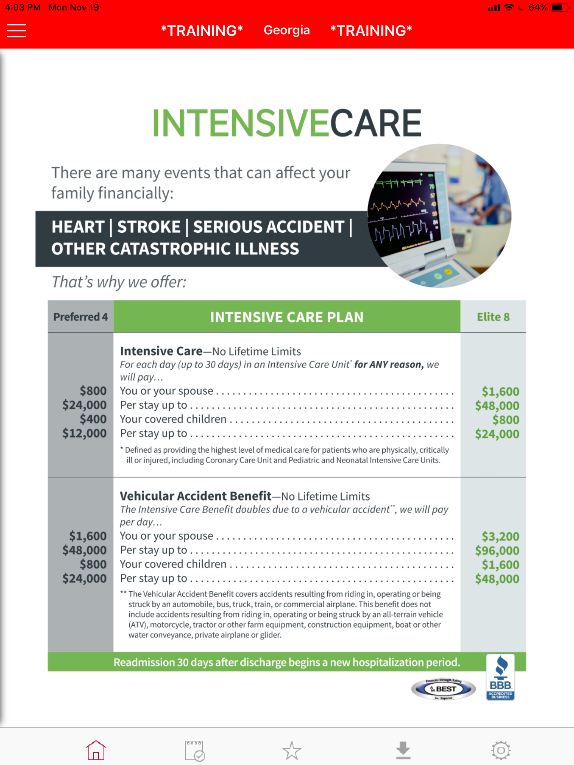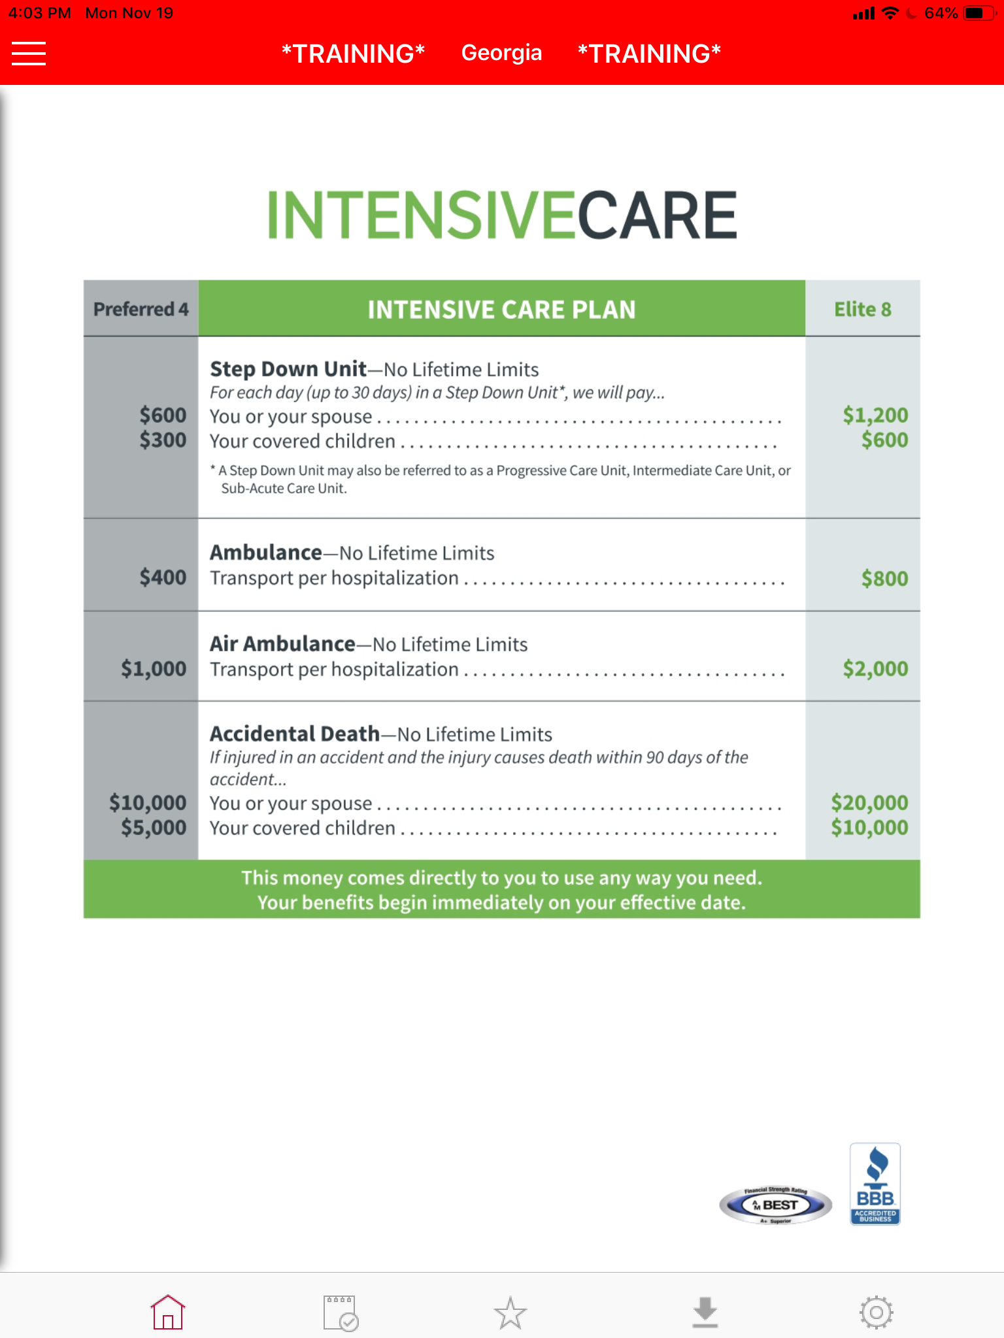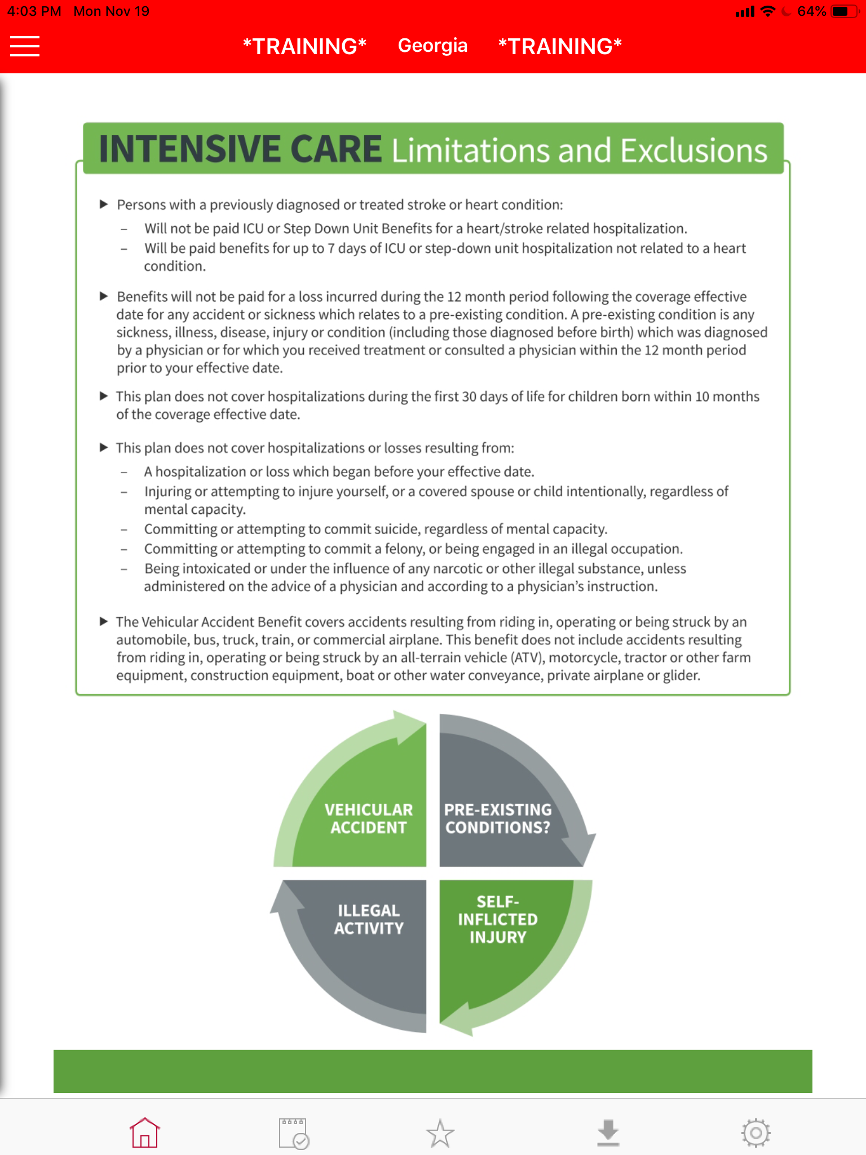
Would you agree that in addition to cancer, other events can affect your family financially? Heart attacks, strokes, serious accidents, other catastrophic illness? That’s why we also provide an ICU Plan. The intensive care part of the plan will pay you $____ per day for anything that puts you (or your spouse) in the ICU. It’s half of that amount for kids. If it’s a vehicle accident it doubles to $_____.

(next page)

It also includes an accidental death benefit. This rounds out your coverage to cover other serious things that could happen besides just (cancer/heart/ accidents).

(next page)

ICU Limitations & Exclusions

Does anybody to be covered have a heart or stroke condition?
Anything medical in the past 12 months?
It won’t cover an intensive care stay due to driving while under the influence and for doing anything illegal like robbing a bank.
The vehicular accident benefit doubles if it is a car or truck. If it is an ATV, motorcycle, etc you will just receive the regular ICU benefit, not the double benefit.

(next page)

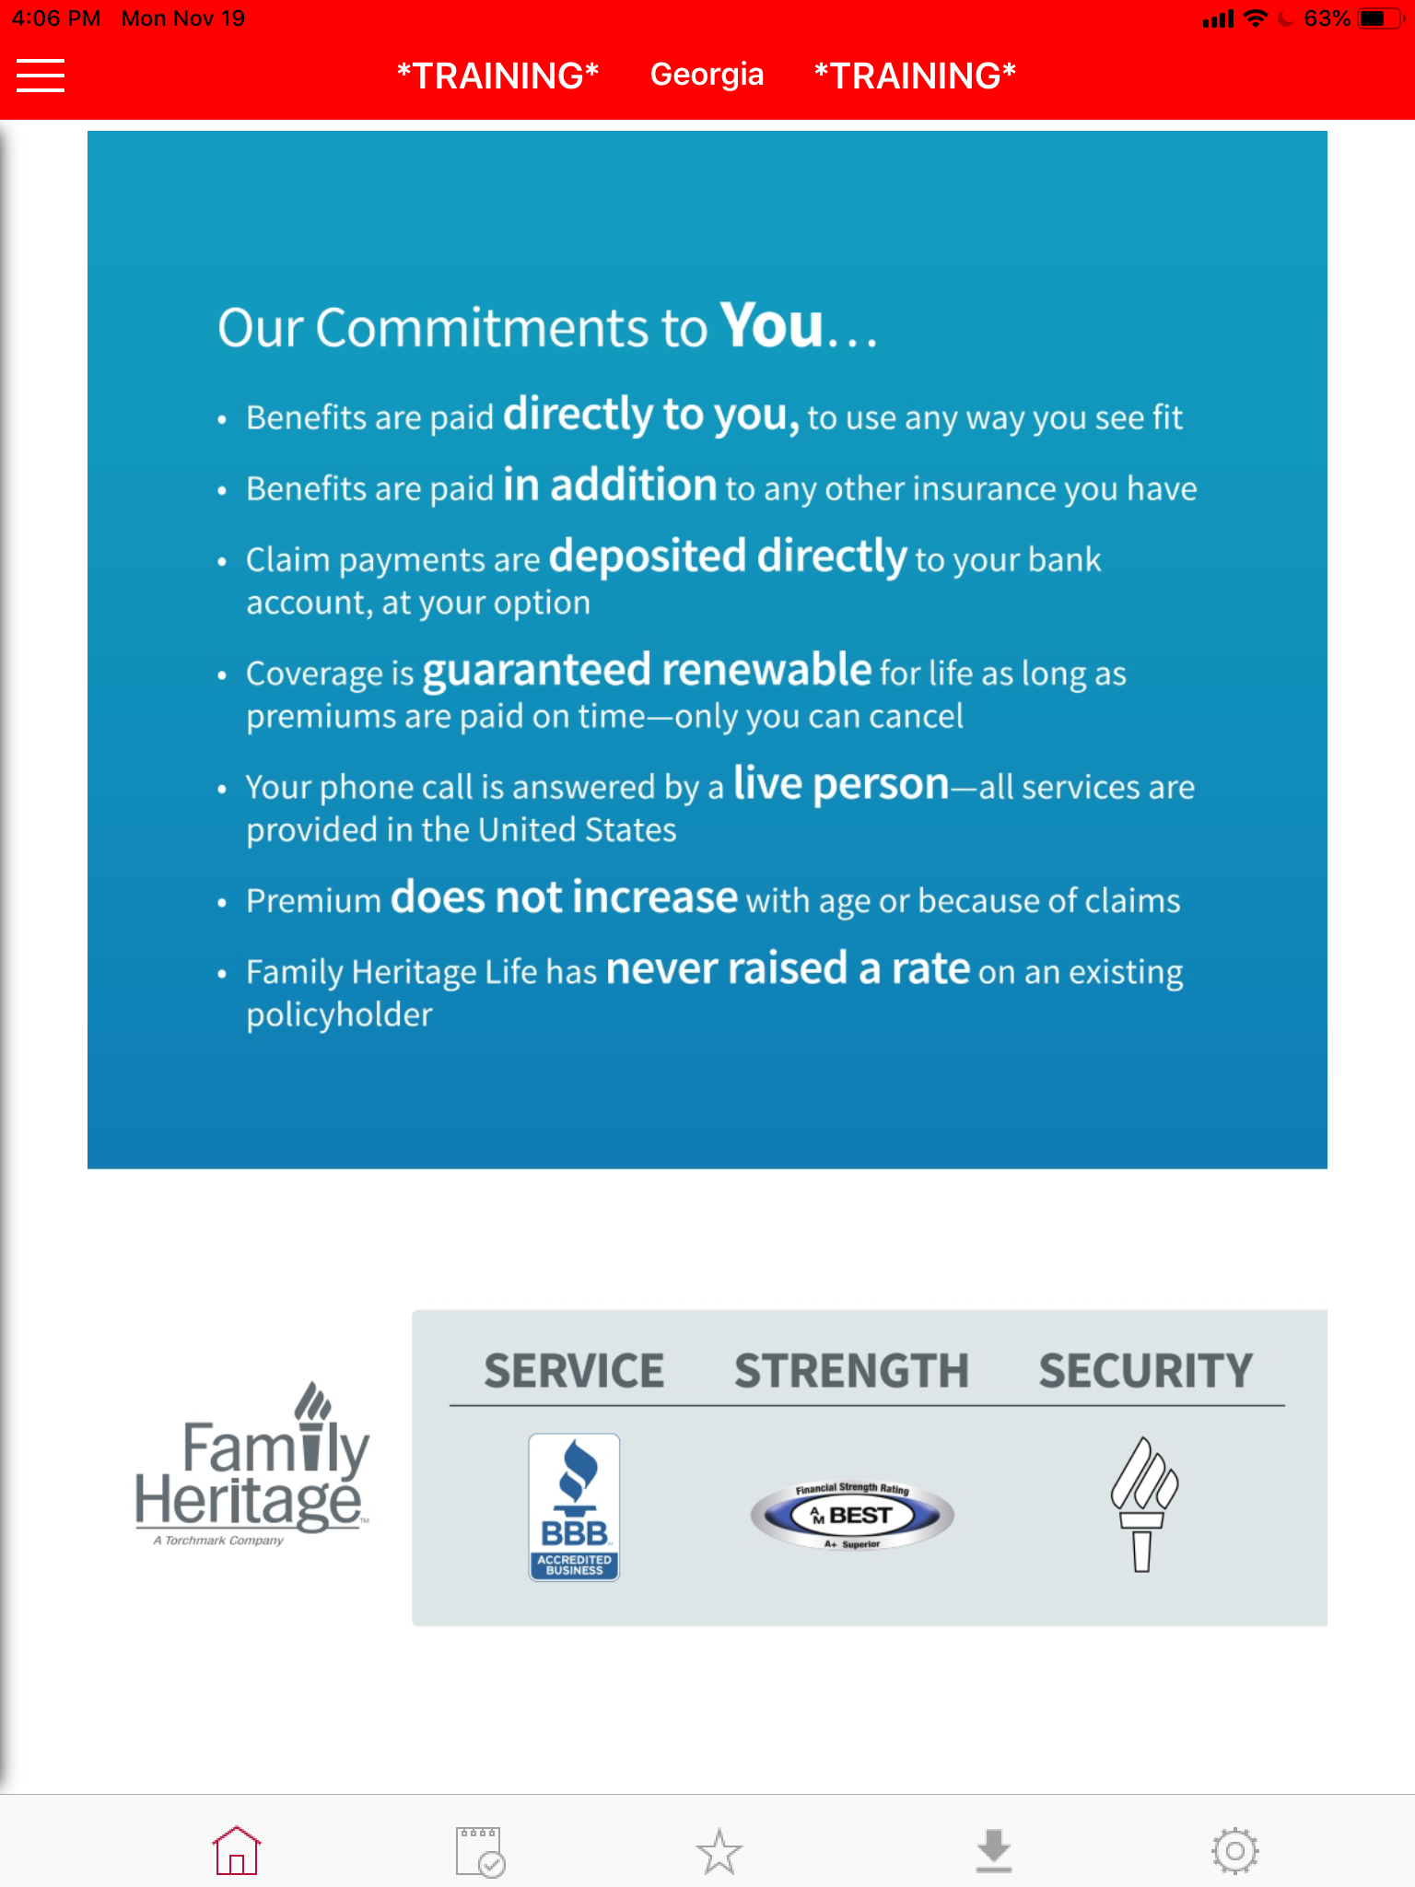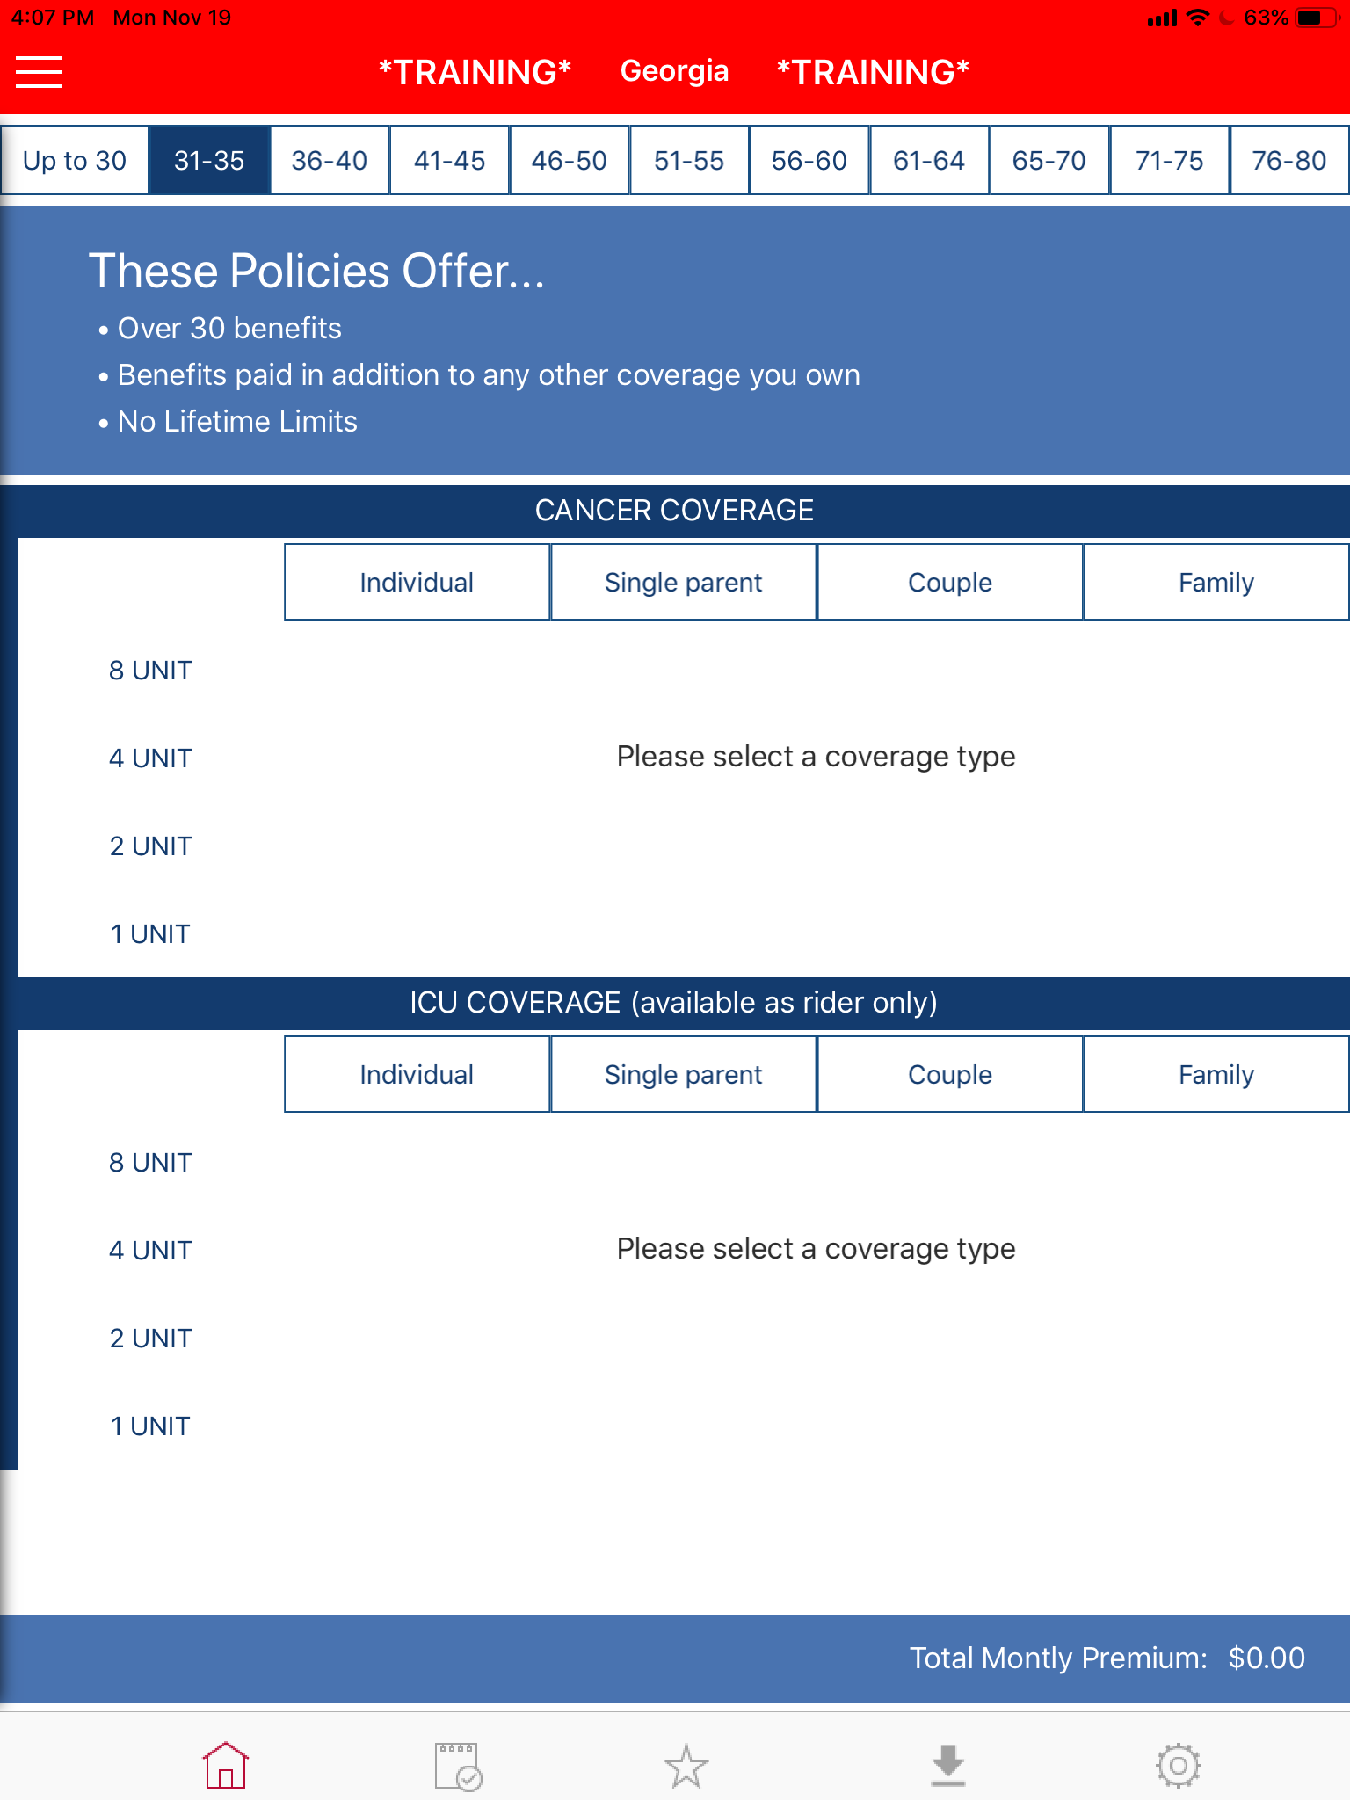

Our Commitments to You…
(read bullet points word for word)

Price Build Up

We go based off age… what age category do you fall in? (if married ask for youngest spouse age)

Let me look up your rate. A lot of people are guessing this policy is going to be expensive with how much it pays out and they start thinking about how much health insurance has gotten.
______, have you ever looked into what your health insurance would cost if you would pay for that on your own?
Some of our clients are self-employed. They’ll write checks from $700 a month on a low end, all the way up to $1200 or $1500 a month.
Most people figure with something like this, that has over 30 benefits, and up to $30,000 per month with no limits, it would be about the same.

(write down top 3 levels on a notepad with total rate including ICU)

But actually to cover all of you guys, it’s not $1200; but actually for you and (your wife, whole family, etc.) on the preferred plan, it’s just $____a month. (look them dead in the eye and show 3 levels) That’s not bad, is it? (smile and nod head)

The Elite will pay out double and it costs about double. The Standard pays half and costs about half.

(next page)
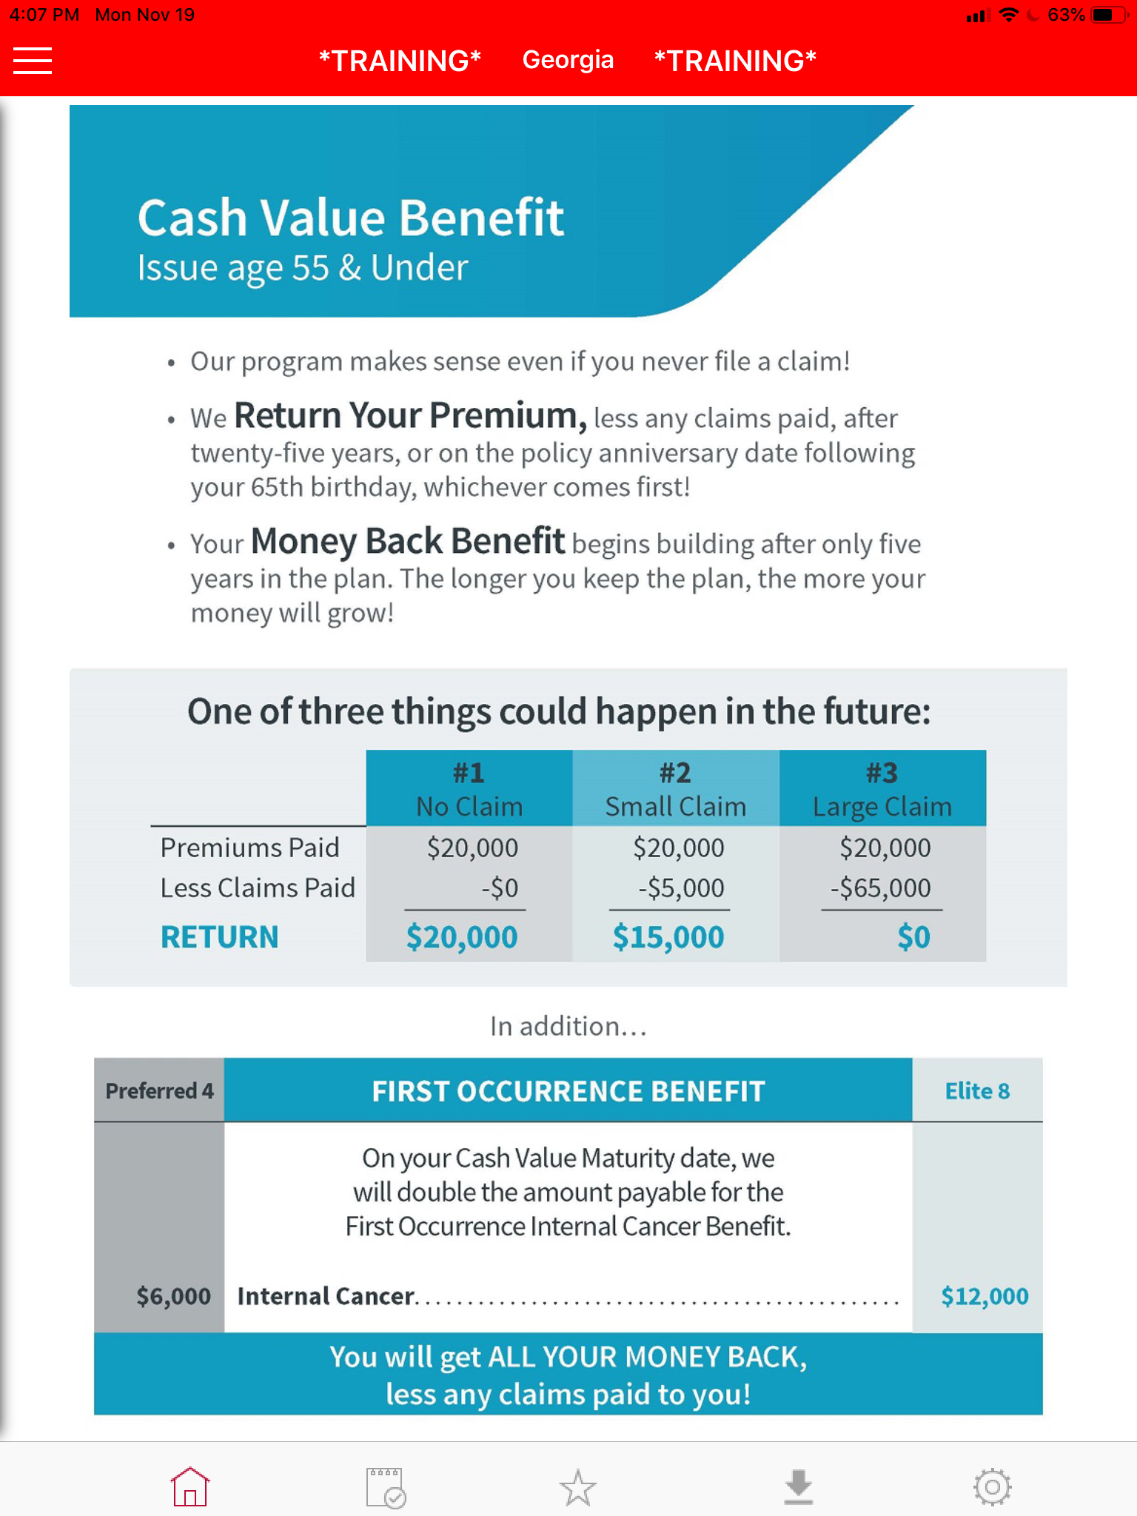
Cash Value / Money Back Benefit (issue age 55 and under in GA)

Plus, our program makes sense even if you never file a claim.

We refund your premium, less any claims paid, after 25 years, or at age 65, whichever comes first.

So one of three things will happen in the future. To give you a real life example of how the money back will work in your situation… which level do you want me to use as an example? (show 3 levels again from when you wrote them on your notepad)

Hopefully you never have to file a claim. In that case you’ll get a check back for 100% of what you paid into the policy. (calculate the money back (monthly premium x 12 x 25 years or until 65) and show them the total) That’s a good day to get the mail!

If you have a small claim, like skin cancer, and we paid you $5,000 we will send you a check for the difference. (subtract $5,000 from the money back total)

The last scenario that could happen would be, heaven forbid, you have a large claim… where we would pay you 60, 70 or $80,000. Obviously you won’t get your money back, but it did what it’s supposed to. You essentially got your money back plus thousands of dollars in the form of a claim.

(stay on the money back page as you go into the Transition to Close)

Transition to Close

Don’t you wish all your insurance worked like this?

It’s a Win-Win situation. If you have a claim, we could pay you thousands of dollars. If not, you get all your money back. The only way you lose is if you don’t have the policy when you need it.

(Pull out your names list, referencing Names and Reasons enrolled)

Everybody gets this for different reasons. I know when I was talking to _______, they really liked that the money was paid directly to them. _________ liked how affordable it was. I know _______ really appreciated the money back part.

Now that you’ve seen how the whole thing works… for you, WHAT appeals to you about the coverage?

Thinking through your situation WHY do you feel like having a plan like this in place would be important? (lean back, nod head)

______, hopefully you never need this but if something serious did happen - HOW would it feel knowing you had this coverage in place?

That’s exactly what this is for.

What everybody likes about the way we do business is…

(go to application and close)

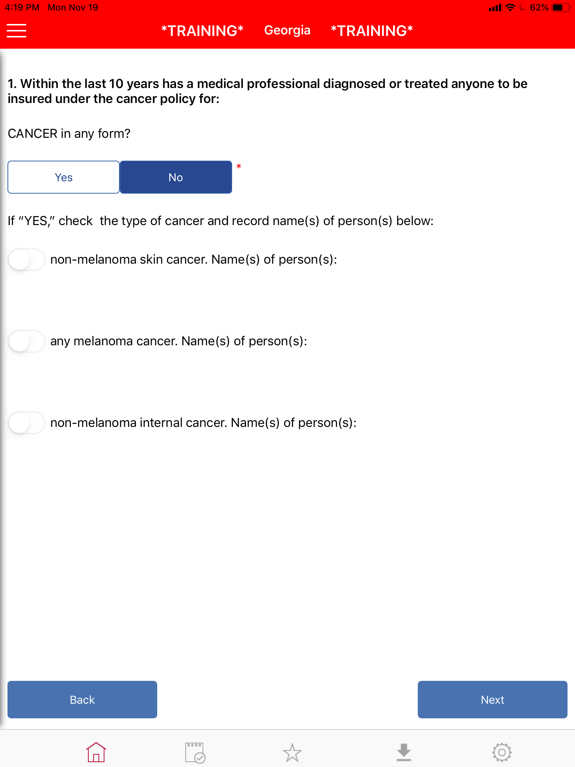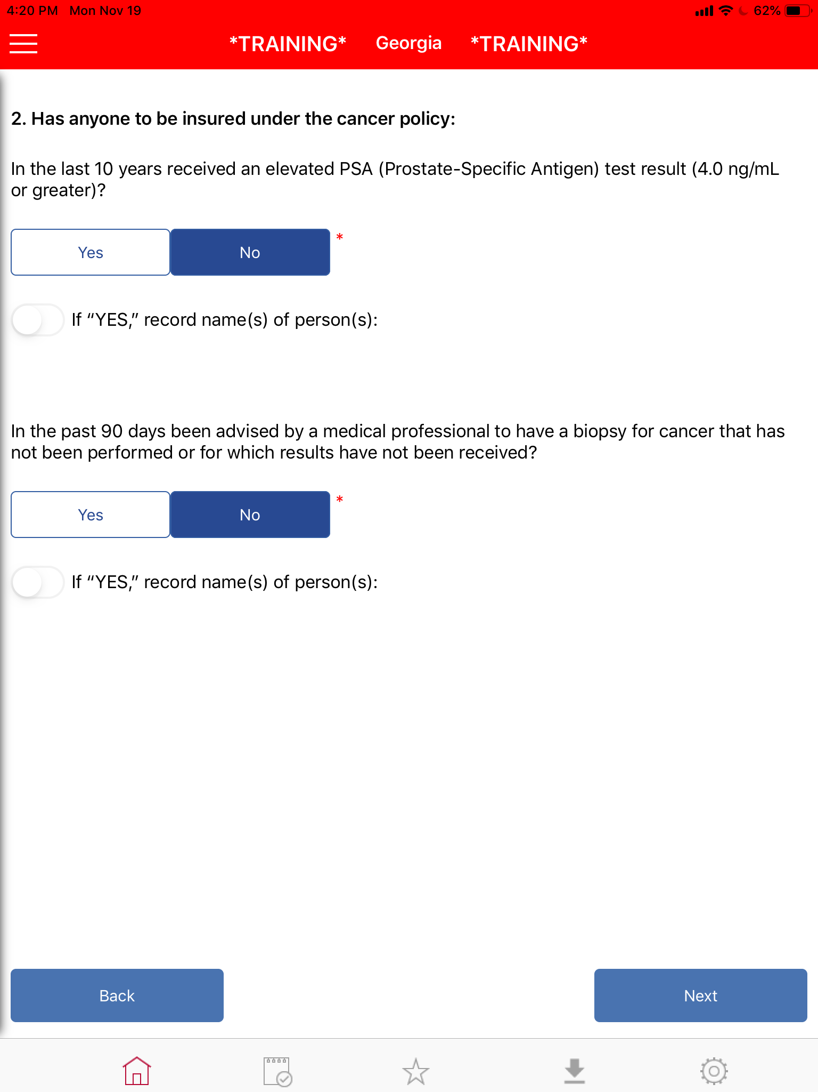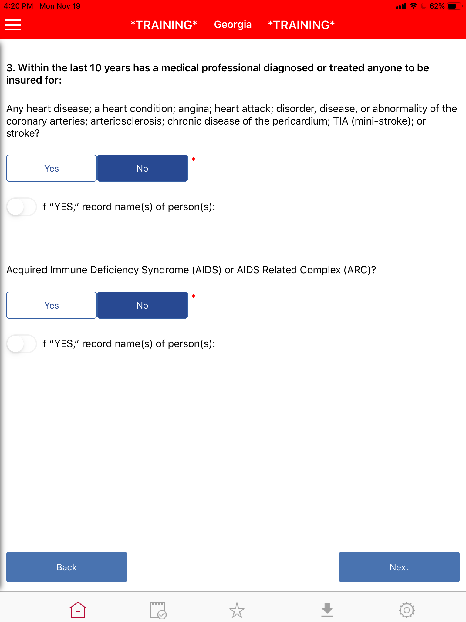

Close

And, _______ (first name), what everybody likes about the way we do business is the application process is pretty simple. We just need your name, address, date of birth, and I’ll need to ask you a few health questions to see if you qualify. It sure is nice having a simple application isn’t it? (smile and nod head)

And there’s 3 easy ways to take care of it: monthly, semi-annually, or annually. It’s nice to have options of how to take care of it, right? (smile and head nod)

But let’s make sure you qualify first. (read health questions)

Congratulations, you qualify!

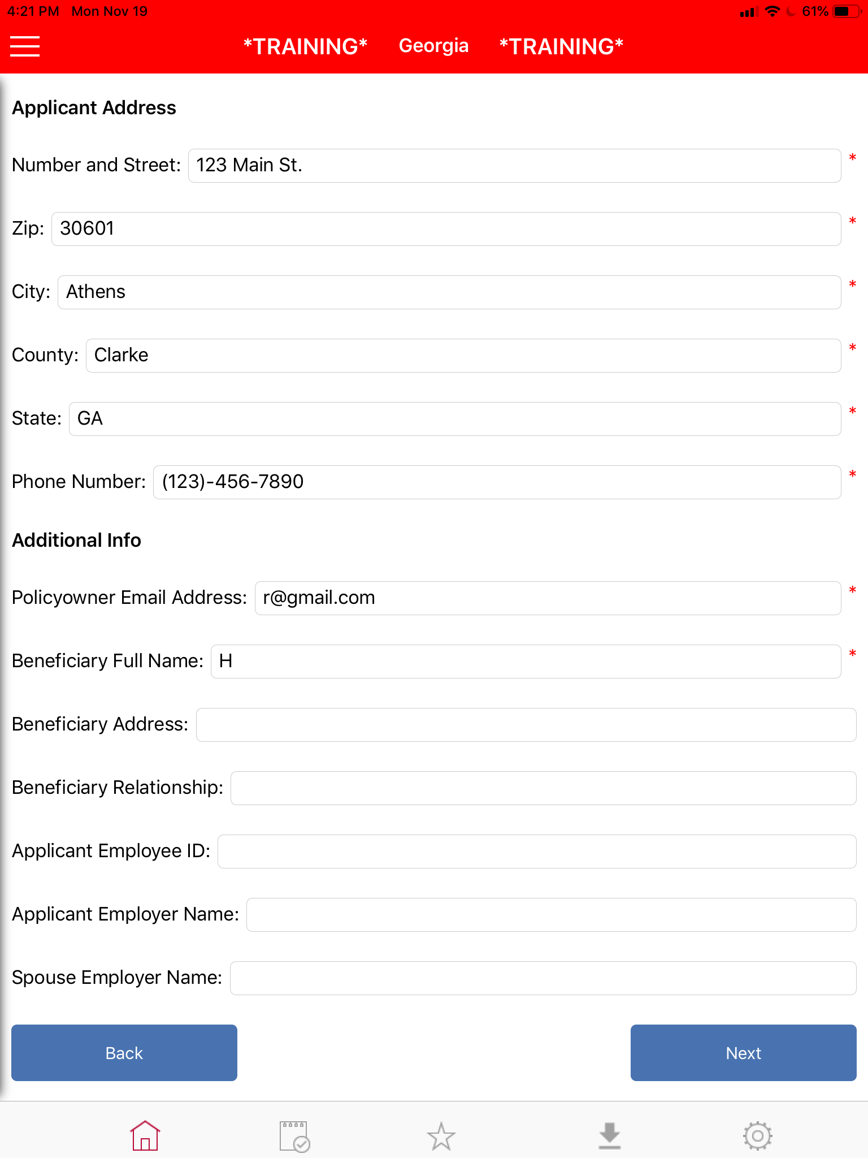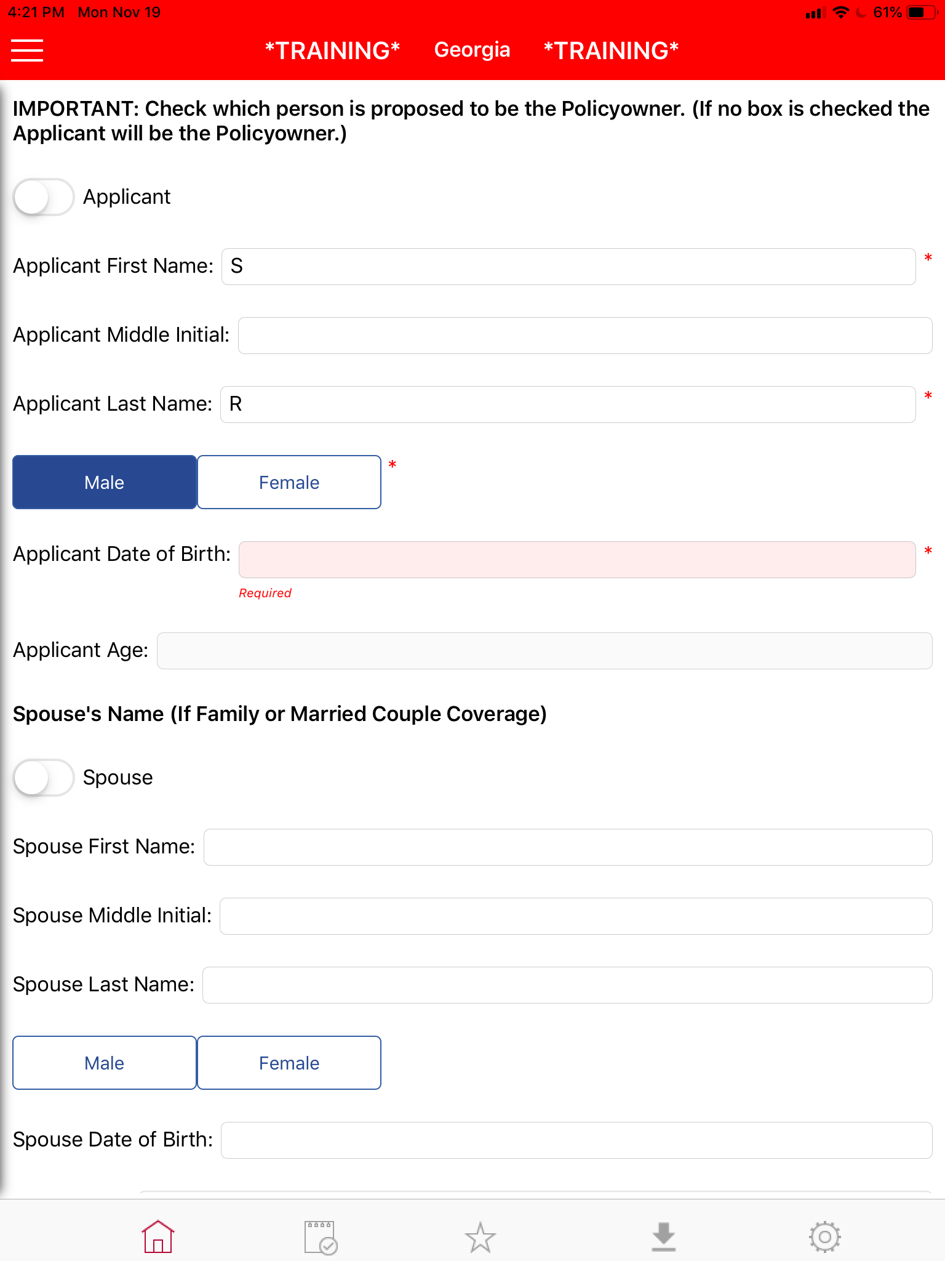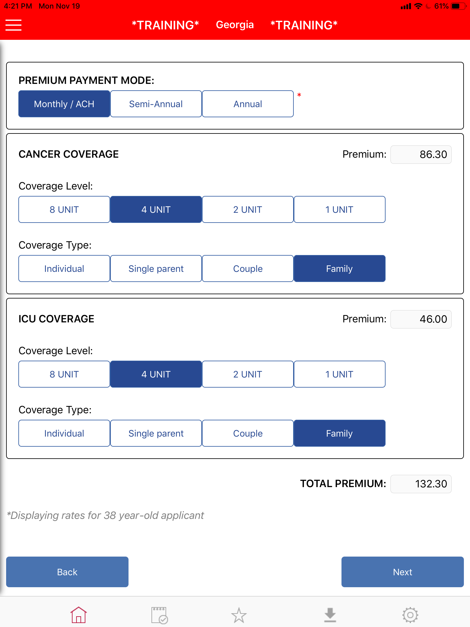

We will take your application, send it to the home office and they will send your policy in the mail in a few weeks. Do you get your mail, here or at the post office?

(put your head down and look at application)
What’s the address?
What’s the best number to reach you?

(back to top of application)

Is ______ your legal first name?
Middle initial? Last name? (always confirm spelling)
What’s your date of birth?
So that makes you ___ as of today?
(repeat for spouse if family plan)

Employer’s name? Spouse’s employer’s name?

Who would you want your beneficiary to be?

And we talked about the Preferred coverage which is $____ for the family on the cancer and the ICU. You also have the Elite and the Standard. (show 3 levels again) Which level makes the most sense for you? (circle it on your paper once they pick one)

You can pay for it annually, semi-annually or monthly. Most everybody just does monthly because there’s no discount on semiannual or annual. Which one works best for you?

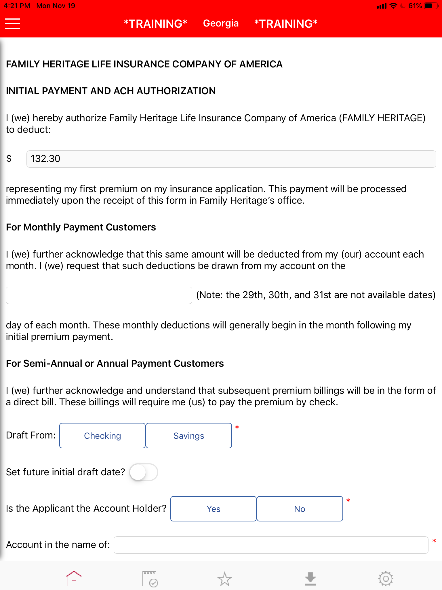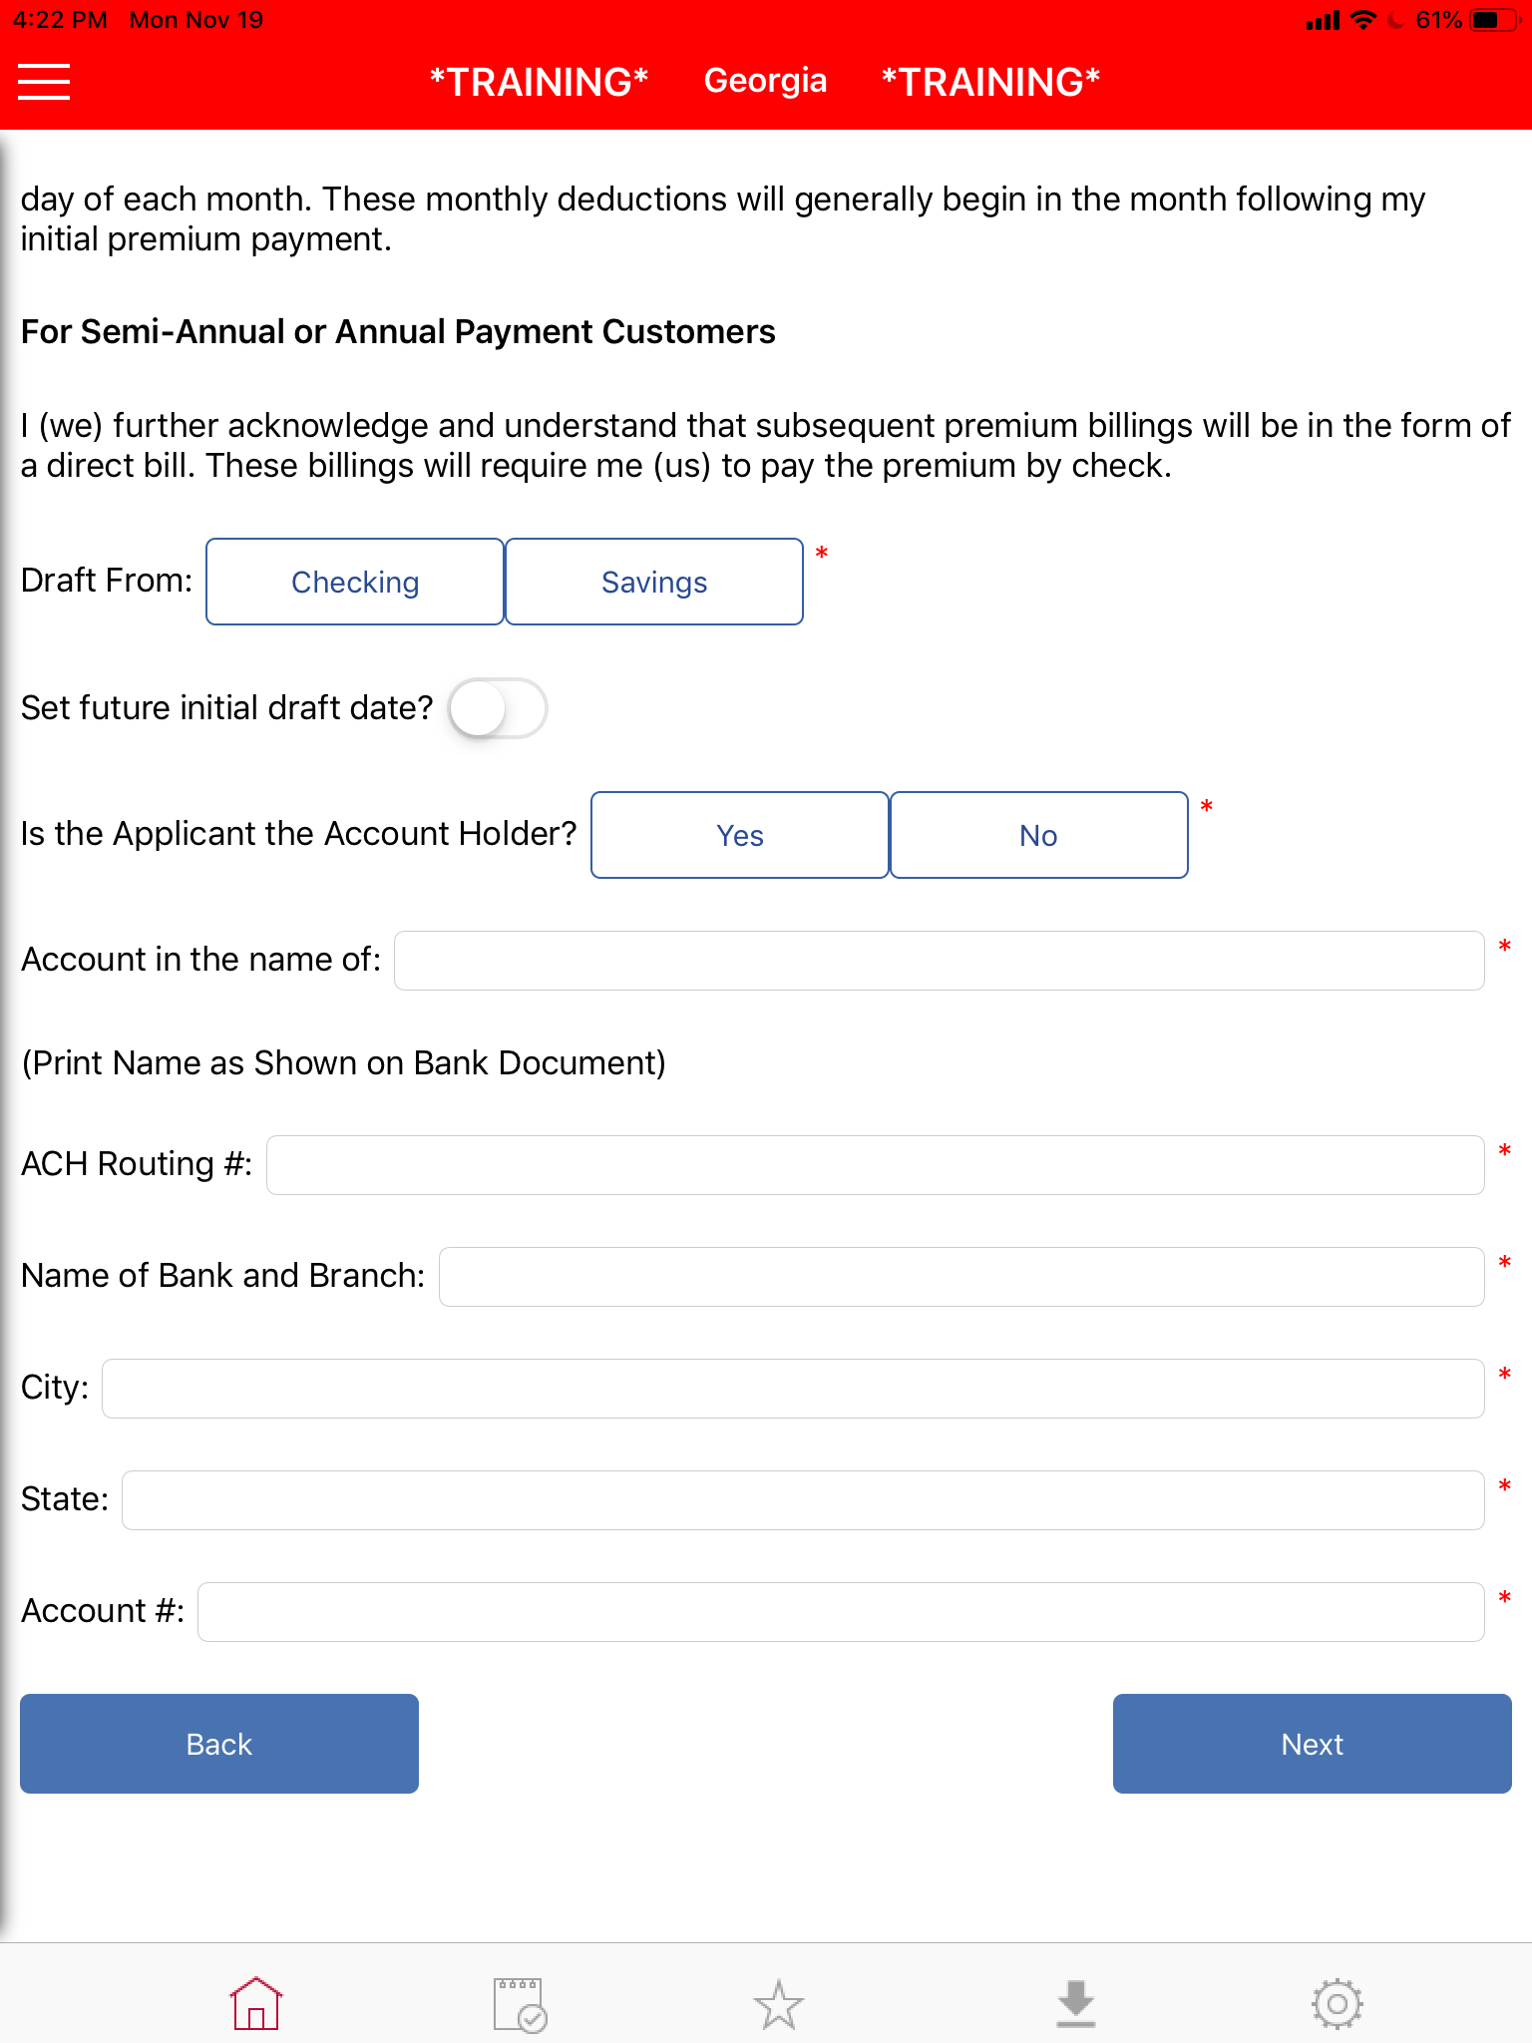

The way it will work is the first payment will be deducted when the application is processed. In future months you can pick a day of the month and they will set up an automatic deduction through that account. Which day of the month works best for you? 1st? 15th? (head down) Will that be checking or savings? Is your name listed as account holder? What’s the routing number? Name of bank? City and state for bank? Account #?

(Review application)

I need you to sign here. This is stating that you were truthful about the health questions, we have it set up for a monthly deduction, and that you understand the benefits are paid directly to you; not to doctors or hospitals.

Solidifying the Sale

1. Write your name on their brochure and your phone number.

2. Circle their level of coverage .

3. Circle and explain the wellness benefit, and quickly review the travel benefit.

4. Write down their total amount they’ll be getting back in the Return of Premium if they stay totally healthy.

“And _____, like I said, you’ll be getting your actual policy in the mail in 2-3 weeks. If you have any questions, feel free to call me. Do you have any other questions?”

Getting Referrals

There is one last thing I could get your help with. (pull out referral book)
The hardest part of my job is running into people that wish they could get this coverage but don’t qualify. My job is to get the word out before its too late. Who do you know that would at least benefit from hearing about this?

(Give them memory-joggers if/when they stall)

Do you have family in town? Brother and sisters? What’s your brother’s name?
How about friends? People you go to church with? Who was in your wedding?
Who do you know that owns a business in town?
What other businesses do you guys work closely with?
Any competitors?
Any suppliers?
Other branches?
Neighbors / other businesses on the block?

(Proceed to get information in layers… best time to see, who to ask for, addresses, etc)

Who is the decision maker? When is the best time to catch them?
How many employees?
Where do they work? (individuals)
When is the best time to catch them? During the day or after 5?
Is it just Joe there? Is he single or is he married?
Thank you so much. This really helps.

Field Recruiting

Our agency is growing in the area and we are looking for people to join our team. Who do you know that…

- wants to have uncapped six-figure earning potential?
- is great with people and has a heart of service?
- wants to work a better schedule (less nights/ weekends)?
- wants to build a residual income?
- has an entrepreneurial mindset?
- is getting ready to graduate college?
- has a desire to lead and mentor others?

1st Rebuttal
I totally understand how you feel, _____ (First name/s). A lot of families kind of felt the same way until they realized what this could mean for their family. (Read Claim)
Not that they ever planned on using it, it just kind of happened. Fortunately they were prepared.
I hope that you guys never have to go through anything like that. But we never can tell, can we?
And if someone in your family were ever diagnosed as having cancer, I know that you would want to them to have the very best treatment, right? We both know that getting the best treatment can make a big difference and be pretty expensive, right?
If all this policy did was give you the ability to get the kind of treatment that you wanted instead of only what you could afford, it would be well worth having, wouldn’t it?
So why take the chance when you know that if you never need it, you will get all of your money back?
That just makes sense, doesn’t it?
Okay great…. (Continue where you left off in the application)

2nd Rebuttal
I totally understand how you feel. Usually most people ask themselves three questions to help them make the best decision. One is ,not that you ever plan on it, but do you think it’s at all possible any in the family could go through something serious health-wise like cancer in the future?
Hopefully not. Two is… Would the thousands of dollars that we pay you help out?
I guess the last one is: $15 a week… That wouldn’t cost you guys to miss any meals, would it?
But probably could provide some if something were to happen. Most people figure why take a chance especially if you get all your money back? I mean, that just makes sense, doesn’t it?
Most everybody just does monthly because there’s no discount for semi-annual or annual. Which one works best for you? (continue where you left off in the application)
3rd Rebuttal
______ (first name/s), this is just the application part. How this works is… Hopefully you never have to go through something but if something happens right away, you’re covered. It’s really nice because your actual policy will come in the mail in two to three weeks. How this works is we just get started today and when you get the policy in the mail the state gives you a 10 day free-look option to look over the policy and feel good about what you are doing. You can cancel at that point and receive a full refund of your first month’s premium. It really takes the pressure off of you guys. But, we never know what tomorrow holds in store. Does that make sense? (pick up where you left off in the application)

